Chapter 4. Dielectric losses and dielectric spectroscopy

Dielectric losses, describing the transformation of the electrical energy into a heat, are an important electro-physical parameter of the dielectric. The magnitude of these losses, as well as their dependence on frequency and temperature testify about certain features of the mechanism of polarization.
Dielectrics are usually studied and used in the alternating electrical fields. Therefore, it is important to study electromagnetic energy absorption at various frequencies for different mechanisms of polarization and conductivity. Dynamic properties of quasi-elastic and thermally activated polarization are highly different; however, the details of dielectric absorption (dielectric losses) and their frequency dependence were not analysed previously.

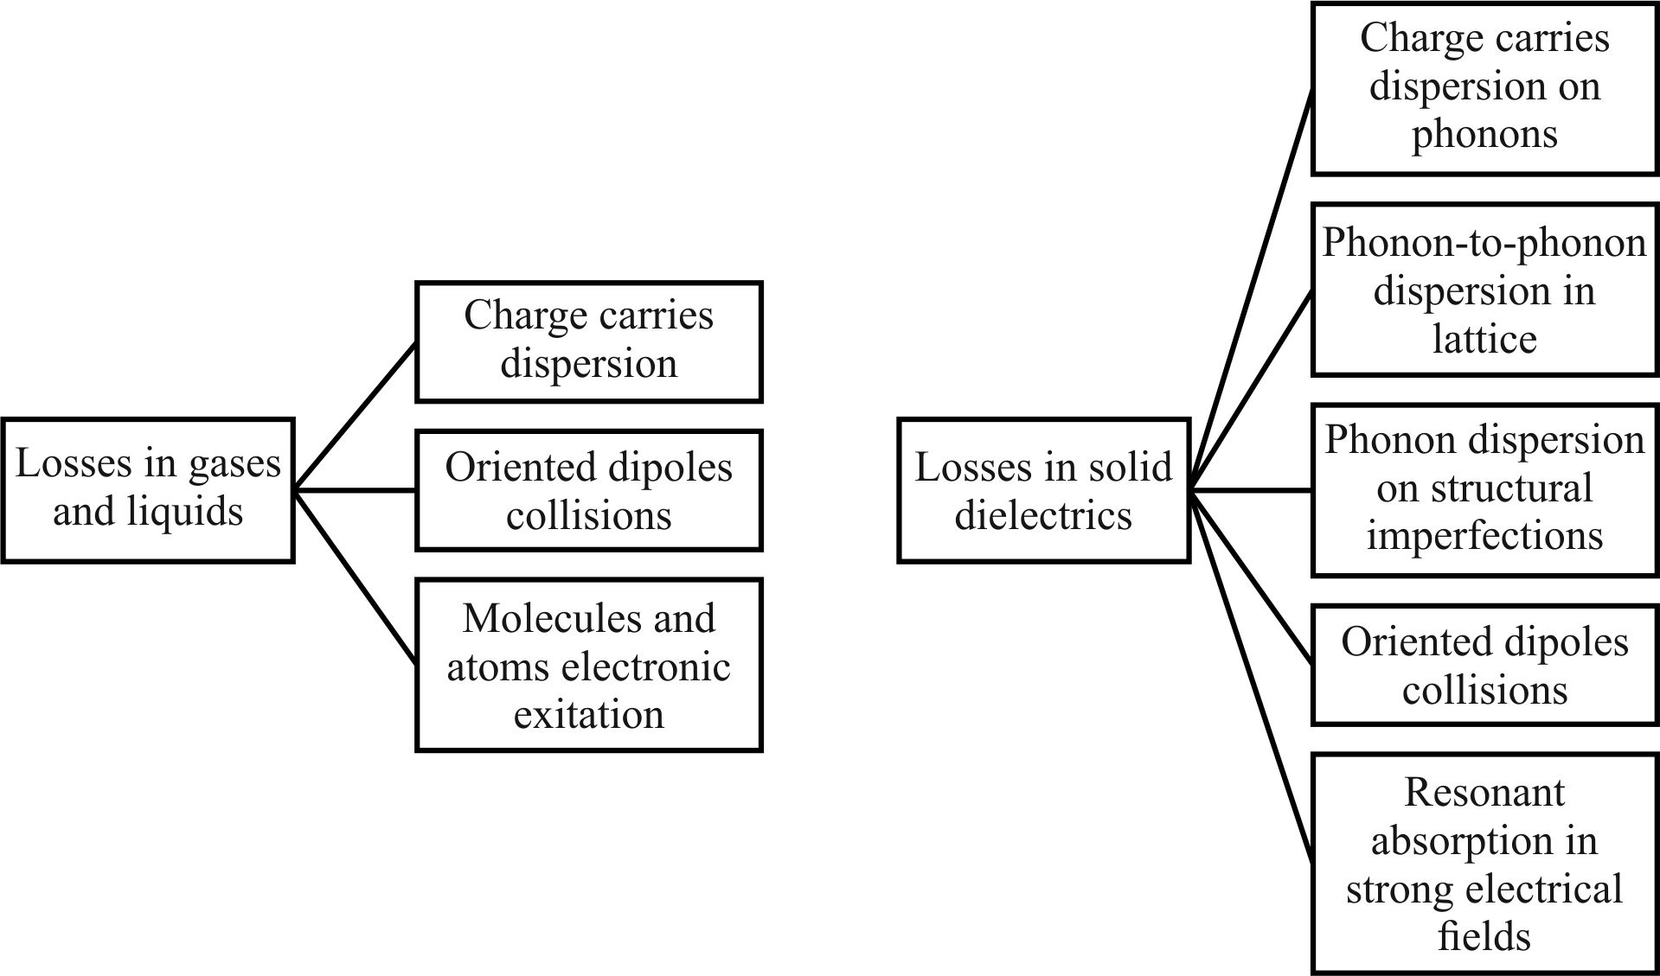
Fig. 4.1. Dielectric losses mechanisms classification

Dielectric losses mechanisms are quite various (Fig. 4.1). In the case of quasi-elastic polarization, the variance of ε*(ω) has a resonant character, with the maximum and minimum in ε′(ω) dependence, Fig. 3.5. In the case of thermal polarization, the ε*(ω) dependence has a relaxation nature and characterized by a gradual decrease of ε′(ω) with frequency, Fig. 3.3. In both cases, in the frequency range of dielectric dispersion, a maximum of loss factor ε′′(ω) is observed.
Equations that describe dielectric losses frequency dependence were presented in the previous discussions; they are summarized in table on Fig. 4.2. Dielectric relaxation at thermal and migration polarization which is described by Debye equations (3.3 and 3.4) are repeated in this table, where formulas for all basic mechanisms of losses are listed. Analysis of these formulas enables to describe the frequency dependence of the parameters ε', ε" and tanδ.

Absorption  mechanism: | Non-inertia  conductivity | Thermally activated polarization  (relaxation model) | Quasi-elastic polarization  (oscillator model)
Parameter:  ε′(ω) | ε(∞) = ε | ε(∞) +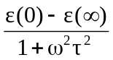 | ε(∞) + 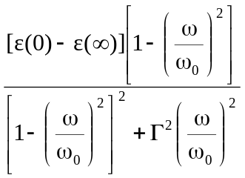
ε′′(ω) | σ/(ε₀ω) | 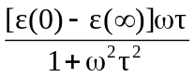 | 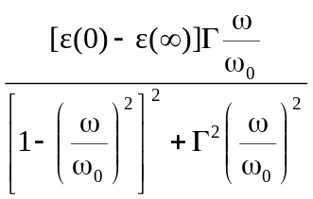
tanδ(ω) | σ/(ε₀εω) | 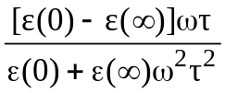 | 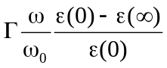  (at ω << ω₀)
p(ω) | E²ε₀εωtanδ = σE² | ε₀ε′′ωЕ ² | ε₀ε′′ωЕ ²
ε′′_{max}(ω) | − | 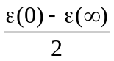  (at ω = 1/τ) | 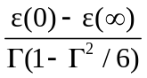  (at < 1)

Fig 4.2. Basic formulas describing the various mechanisms of losses

The simplest mechanism is the charge carriers scattering in a matter, in other words, this is the electrical conductivity. These losses, in one way or another, can be seen in all dielectrics – in gases, liquids and crystals. Dispersion of charge carriers is due to their collisions with atoms and molecules (in the disordered media) as well as their scattering by lattice vibrations and structural defects (in the crystals). Conductivity is the most important mechanism of electrical energy conversion into a heat in the semiconductors.
Specific mechanism of energy absorption in dielectrics is losses originate from polarization. In an alternating electrical field polarization of dielectric is always accompanied by electrical energy dissipation (every non-stationary process in real materials is always more or less thermodynamically irreversible). At some frequencies, however, polarization losses can be very small, but they never can be absent.
Dielectric losses usually vary considerably depending on the presence of various impurities in the dielectric. In solid dielectrics, depending on the concentration of impurities or structural defects, the value of dielectric losses may vary by tens and hundreds of times, while the change in permittivity might be rather small. For this reason, dielectric losses are the most sensitive indicator of the structural defects in dielectric. Therefore, study of dielectric losses and their dependence on the structural defects as well as on various factors (temperature, voltage, frequency) represents considerable interest to physics and application of dielectrics.
Mechanisms of dielectric losses arising in an alternating electrical field can be specified only while study of electrical response dynamic properties (as polarization so conductivity). It is necessary also to take into account the molecules and atoms kinetic properties in the dielectric.

4.1. Dielectric loss tangent

Dielectric losses in electronics and electrical engineering are characterized by the loss tangent: tanδ. However, the most general physical characteristic of losses, particularly for frequency dependences description, is complex dielectric constant:
ε*(ω) = ε′(ω) − ε″(ω), tanδ = ε″/ε′, (4.1)
where ε' = ε, while ε″ is losses factor. In electrical engineering, to determine the loss of electricity, a parameter cosϕ is commonly used, where ϕ is the angle between vectors of electrical field and current, Fig. 4.3. However, to describe the losses in dielectrics, this characteristic is inconvenient, as the angle ϕ usually is very little different from π/2. That is why it is more comfortable to use the angle δ which supplements the angle ϕ to π/2. Parameter tanδ is numerically equal to the ratio of the active (conduction) current j_{a} to the reactive current of bias j_{r}.

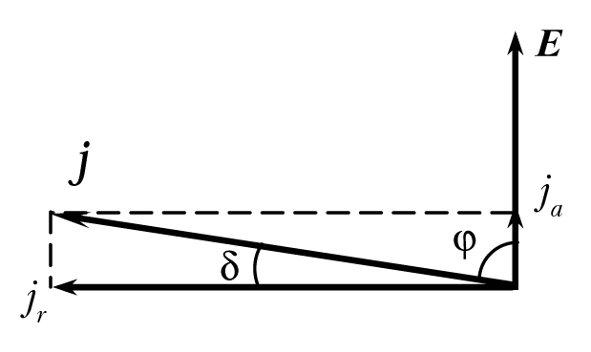
Fig. 4.3. Determination of the loss tangent

Parameter tanδ is the macroscopic characteristic of the dielectric as well as the dielectric constant. Dependence of losses tangent on temperature, frequency, electrical field and other influences is the same important characteristic of dielectrics as appropriate depending on the dielectric constant. It should be noted that that introduction of tanδ as a characteristic has physical meaning only in the case of sinusoidal alternating electrical field.
In the electronic circuits (where dielectric is very often used as electrical capacitor), to describe dielectric losses in real capacitor, it is very convenient to represent it as a combination of ideal capacitor and ideal resistor which simulates the dielectric losses. Several equivalent circuits for dielectric losses description are shown in Fig. 4.4.

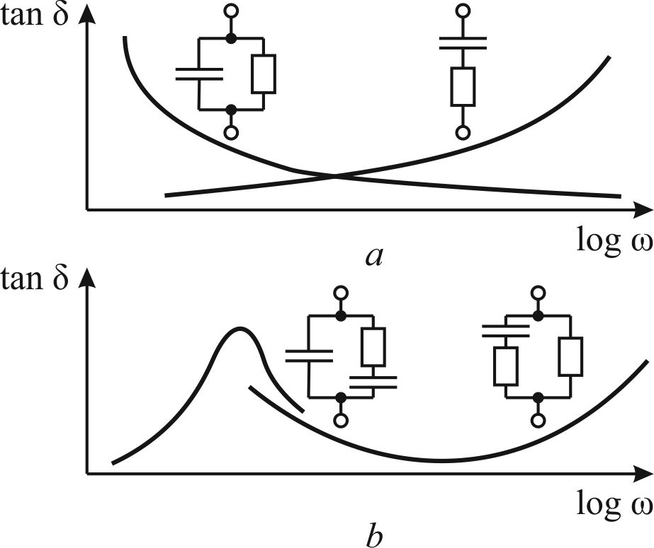
Fig. 4.4. Frequency dependence of loss tangent for different equivalent circuits that describe dielectric losses: a – simplest representation; b – more complicated cases

The parallel connection circuit for real dielectric replacement by the equivalent components (left-hand side in the Fig. 4.4, a) characterizes properties of such a dielectric, in which tanδ decreases with increasing frequency. Generally, this case refers to the losses conditioned by conductivity.
On the contrary, when capacitor and resistor are in the series connection, the frequency dependence of tanδ corresponds to the polarization losses (right-hand side of Fig. 4.4, a). All dependences tanδ(ω) are shown in the semi-logarithmic scale, that is usually used to represent the frequency characteristics.
Thus, one or another equivalent circuit to describe the properties of real dielectric with losses might be selected from its frequency characteristics. Sometimes, it needs to use more complicated circuits that are shown with the correspondent frequency dependence of tanδ in Fig. 4.4, b. In this case, by the combining of various connections of capacitors and resistors, it may be obtained almost complete matching of equivalent circuits with real characteristics of the dielectric. Figure 4.4 b shows the equivalent circuits corresponding to both the frequency maximum and frequency minimum of tanδ.

4.2. Dielectric losses conditioned by conductivity

Rather simple mechanism is the dielectric losses conditioned by conductivity. While directed movement of charges carriers (their drift or diffusion in the external field), during their free path, carriers acquire an energy from the electrical field. Acquired energy is spent in "collisions" that are, actually, the interactions of charges carriers with molecules and atoms which are in a state of thermal motion. Giving back acquired energy during collision, charge carriers increase the intensity of chaotic motion of particles of matter; therefore, raises the temperature of dielectric. For this reason, the electrical conductivity increases in dielectric its loss factor ε", specific power p (energy dissipation per unit volume) as well as tanδ.
In this case, all these parameters depend only on the density of active current flowing through the dielectric. Corresponding formulas are shown in table on Fig. 4.2. From them it follows that conductivity determines the magnitudes of ε" and tanδ mainly at low frequencies: both of these parameters decrease with frequency as 1/ω. However, the specific power p in this case does not depend on the frequency because it equals to product of frequency independent conductivity and squared electrical field (р = σЕ²). Thus, the reducing of ε" and tanδ with increasing frequency no means the specific power p reduction in dielectric with increasing frequency, as parameter p does not depend on the frequency.
Frequency characteristics of considered parameters are shown in Fig. 4.4, a. In the case where no absorption mechanisms exists other than the electrical conductivity, the dielectric constant is determined only by the fast polarization processes: ε(ω) = ε(∞), and it is frequency independent.

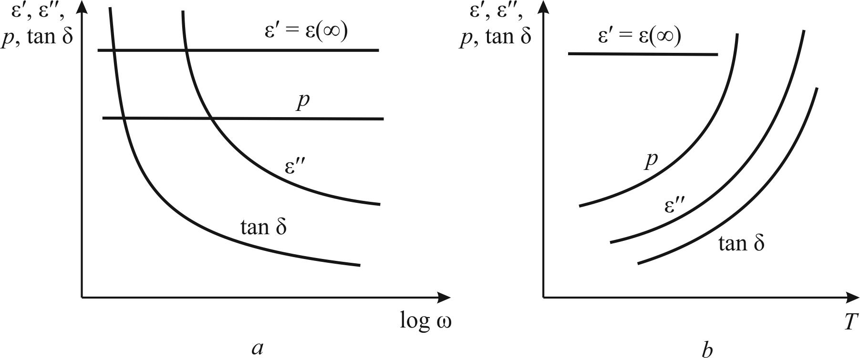
Fig. 4.5. Frequency (a) and temperature (b) dependence of basic parameters of dielectric,
in which conductivity losses dominate

The temperature dependence of losses parameters in the case when the predominant mechanism is electrical conductivity are shown in Fig. 4.4 b. All of them, except ε(ω) = ε(∞), show exponential increase with temperature, since just by this law the conductivity varies with temperature. It is seen that electrical conductivity contributes significantly to tanδ and ε" mainly at high temperatures and at low frequencies. At very low temperatures and at very high frequencies the contribution of conductivity to dielectric losses usually is so small that it can be neglected.
At present-day electronics dielectrics and semiconductors are widely used in microwave technique. Their permittivity (ε = ε′) is practically independent on frequency. In semiconductors, the electronic conductivity dominates. At that, conductivity also is independent on frequency, including terahertz range due to the high mobility of electrons.
Therefore, loss coefficient ε″ = σ/(ε₀ω) and tanδ = σ/(ε₀ε′ω) decreases with frequency, Fig. 4.5, a, because the active component of current j_{a} is frequency independent while reactive component j_{r} linearly increases with frequency while tanδ = j_{a}/j_{r}.
Conditioned by electronic conductivity temperature dependence of losses is shown in Fig. 4.5, b. Fast charge carries provokes losses that are strongly dependent as on frequency so on temperature:
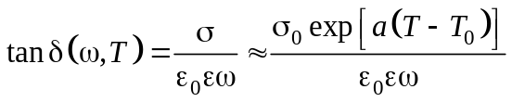, (4.2)
where σ₀ is specific conductivity at certain temperature T₀, parameter ε₀ is electrical constant and ε is frequency independent permittivity, while a is peculiar parameter for a given material.
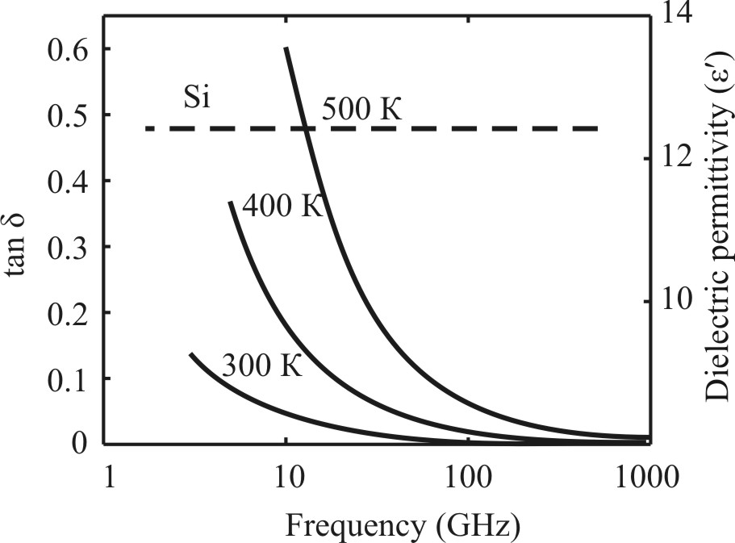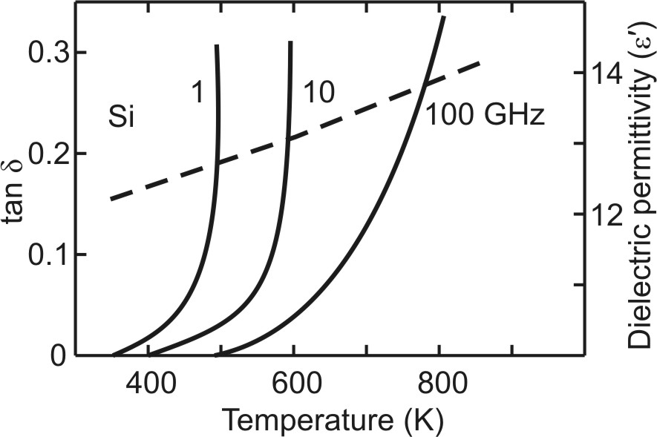
a b
Fig. 4.6. Frequency (a) and temperature (b) dependences of microwave losses tanδ (solid lines) and permittivity ε′ (dashed lines) for the high-resistance silicon in the gigahertz range
If in specified frequency range dielectric shows no relaxation or resonance ε-dispersions, the ε′ω) remains constant, while ε′′(ω) depends on conductivity σ and decreases with increasing frequency:
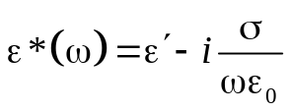, (4.3)
This equation is not a dispersion one, inasmuch as describes only the ε″(ω) dependence that is not concerned with ε′ = Const. In the case when σ is independent of frequency, the conductivity does not contribute to the real part of permittivity.

4.3. Dielectric losses conditioned by thermally induced polarization

Relaxation polarization is caused by directional local electro-diffusion process, at which weakly bounded charges are accumulated in definite localized states (or dipoles are directionally oriented). Due to the thermal motion, this kind of polarization is settled relatively slowly. Relaxation time of this polarization varies with temperature in the limits of 10⁻³…10⁻¹⁰ s (at normal conditions, i.e., round 300 K). Thus, the distinguishing frequency of the molecular relaxation processes in such dielectrics may be located just in the frequency range, where dielectrics are used in electrical engineering and electronics (50 Hz...100 GHz). On the contrary, quasi-elastic (deformation) polarization is quick enough in order to have any influence on the losses in this frequency range.
Therefore, in most cases, technical use of dielectrics with thermally activated polarization leads to the undesirable dielectric losses. On the other hand, the migration (space charge) polarization, is too slow mechanism and leads to losses in the infra-low frequency range (10⁻³…10² Hz).
Dielectric relaxation of thermal and migration polarization is described by the Debye equations (3.3 and 3.4) that are repeated in the table on Fig. 4.2, where formulas for all basic mechanisms of losses are listed, including parameters that characterize the relaxation losses. Analysis of these formulas enables to describe the frequency dependence of the parameters ε', ε", and tanδ.
At low frequencies (ω → 0) permittivity is marked as ε' = ε(0), while at high frequencies (ω → ∞) permittivity is ε′ = ε(∞). While frequency is reduced, at value of ω = 1/τ, the dielectric contribution decreases exactly twice (Fig. 4.7, a). If conductivity is absent, the loss factor vanishes (ε" → 0) as at very low frequencies (when ω → 0) so at very high frequencies (when ω → ∞). It is easy to show that ε″(ω) has a maximum just at the frequency of ω = 1/τ where the dielectric contribution to permittivity decreases two times.
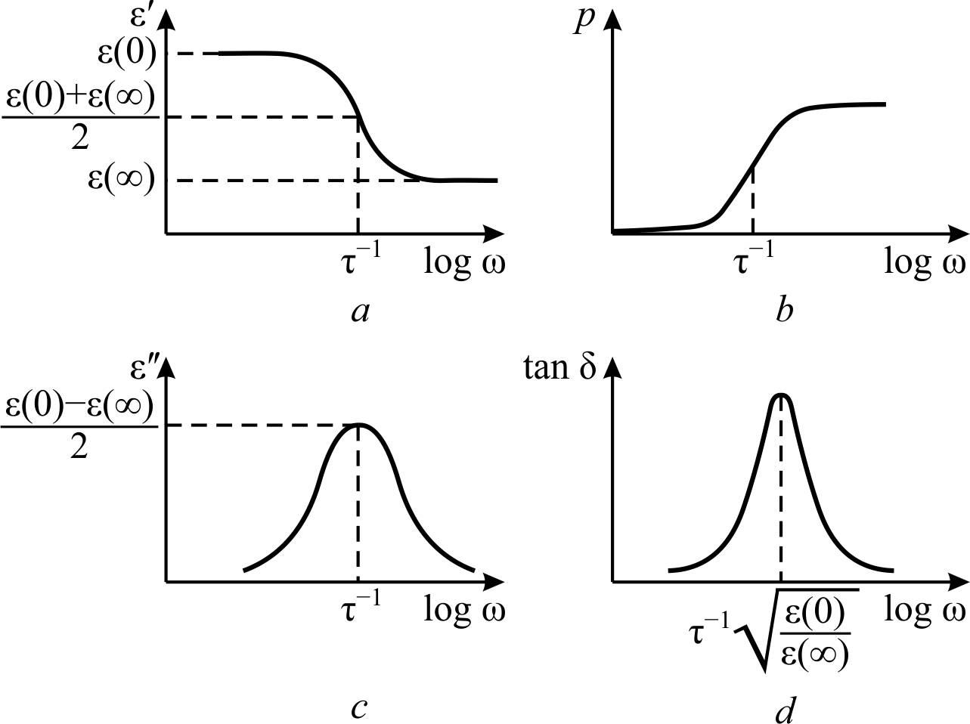
Fig. 4.7. Frequency dependence of dielectric constant (a), absorbed energy density (b), loss coefficient (c) and the loss tangent (d) for dielectrics, in which thermal polarization mechanism dominate

Loss tangent frequency dependence is also characterized by maximum:

tanδ_{max} = 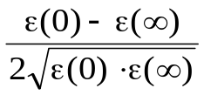, ω_{tanδ max} =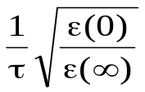. (4.4)
It is obvious that this maximum is observed at more high frequency than the maximum of the loss factor ε″(ω).
From the loss power density p, formula in Fig. 4.2 it follows that at low frequencies, where relaxation polarization can be totally settled in time, the dielectric losses are practically absent, Fig. 4.7, b. In the centre of dispersion (when ω = 1/τ), the loss power is p = 0.5gE², where parameter g = α_{т}τε₀ is the reactive conductivity. At high frequencies the loss power reaches its maximal value of gE² and next becomes independent on the frequency, Fig. 4.7, b.
Thus, although relaxation polarization is delayed, and no longer gives any dielectric contribution, the specific power losses of relaxation processes are maximized. Therefore, for example, while high-frequency and microwave dielectrics developing, the impurities and structural defects (that give low-frequency relaxation) are highly undesirable, since they do not appreciably affecting the ε-magnitude, but significantly increase the losses.
Temperature dependences of ε and tanδ for relaxation polarization are characterized by peaks. In temperature dependences ε′(Т) and tanδ(Т), the temperature change relaxation time should considered: τ = (2ν_{D})^{–1}exp(U/k_{B}T). Here U is potential barrier (that charged particles need overcame at their thermal jumps), ν_{D} is Debye frequency (particles oscillations in crystal lattice) and k_{B} is Boltzmann constant.

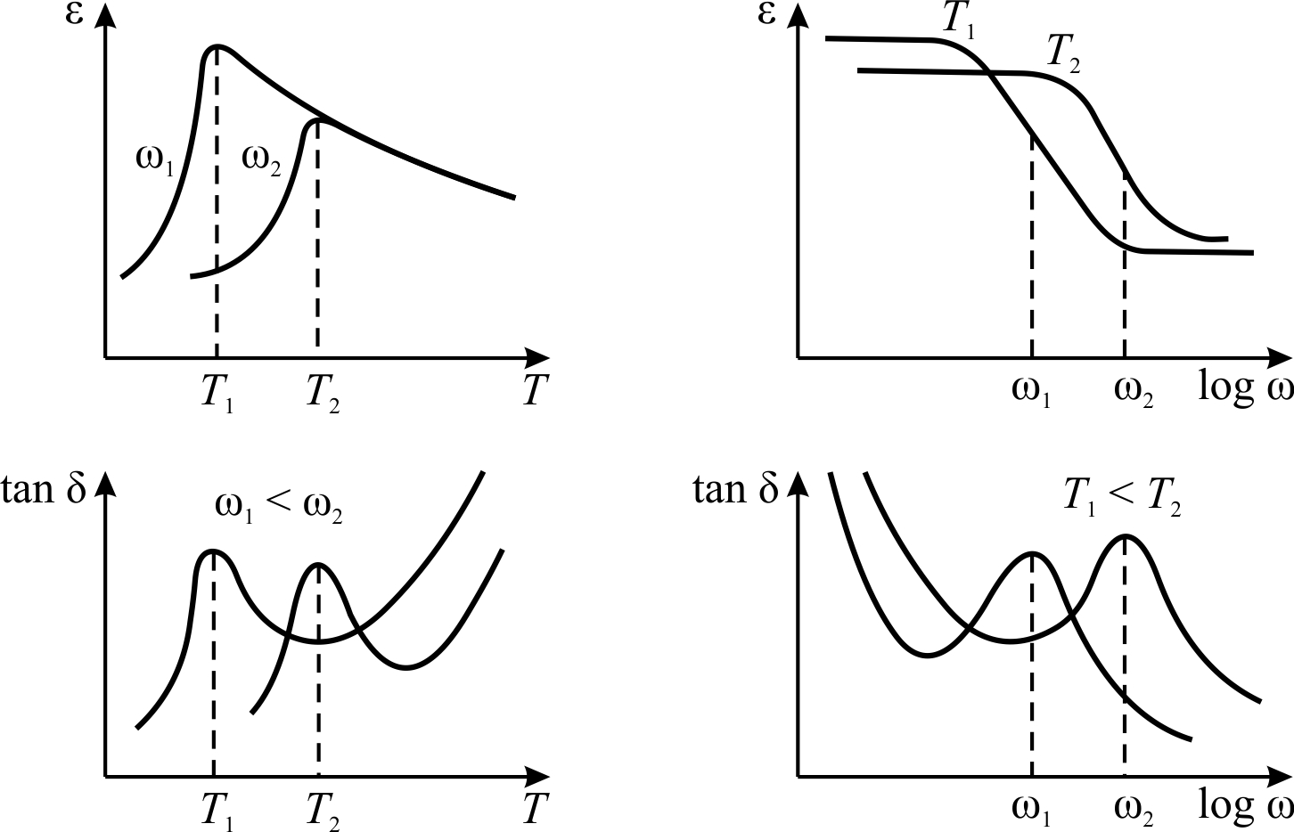

Fig. 4.8. Permittivity and losses dependence on temperature and frequency in dielectrics with conductivity and thermally activated polarization

One has to keep in mind also that thermal contribution to dielectric polarization is dependent on temperature
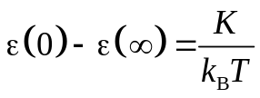, (4.5)
where K is Curie constant (as analogue to paramagnetics). The temperature-frequency dependences of the main parameters of dielectrics, in which not only the thermal polarization but the electrical conductivity clearly reveals as well, are shown in the Fig. 4.8.
Permittivity temperature change in the case of thermally activated polarization is characterized by an asymmetric maximum. In temperature dependence of losses, the almost symmetrical peak is observed. Conductivity has no influence on the ε′(Т) characteristics. However, losses from conductivity are superimposed on the relaxation losses. In compliance with the formula (4.2), the tanδ which is conditioned by conductivity, increases with temperature but decreases with frequency.
Experimental dependences of tanδ(Т) and ε(Т) are the basic data for determining the height of potential barrier U. For U calculation, it is sufficient to determine two temperatures T₁ and T₂ for two values of frequency ω₁ and ω₂ where peaks of losses are observed:
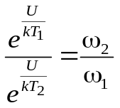, from this it follows that 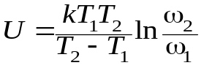.
Theory of relaxation polarization is confirmed by many experiments.

4.4. Dielectric losses conditioned by quasi-elastic polarization

Elastic displacement of shell-electrons in atoms, ionic sub-lattices in crystal or rigidly connected dipoles create polarization. A restoring force is proportional to the displacement of particles from their equilibrium position. Particles that are deviated from the equilibrium position can oscillate around a new equilibrium state. Therefore, dynamic properties of quasi-elastic polarization can be described by an equation of the harmonic oscillator, in which dielectric losses are taken into account by introducing of damping coefficient Г. Dielectric dispersion in the case of quasi-elastic polarization is characterized by the Lorentz formula

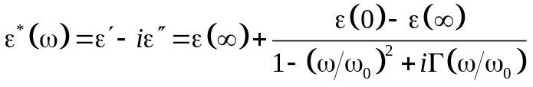. (4.6)
where ω₀ = 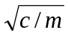 is intrinsic frequency of oscillator, c is elastic constant and m is oscillating mass; ε_{osc} = ε(0) − ε(∞) = nq²/ε₀с is dielectric contribution of n oscillators; Г = λ/ω₀ is relative attenuation (λ is a constant of "friction" that occurs form scattering mechanisms listed in table in Fig. 4.1). Calculation formulas needed to describe the dielectric absorption of oscillator type and dispersion are listed in the table on Fig. 4.2. Figure 4.9 shows typical frequency dependences of ε′ and ε" for damped oscillator.
Loss factor ε"(ω) always is positive, while the value of ε′(ω) might be both positive and negative. At low frequencies (when ω << ω₀) as ε′ so ε" increase with rising frequency while in neighbourhood of ω ≈ ω₀ both of them have a maximum. At further increase in frequency, the dependences of ε′ and ε" are quite different. Real part of permittivity ε′(ω) drops sharply, and at a frequency ω = ω₂ reaches its minimal value (Fig. 4.9, a). Then ε'(ω) again increases with frequency, and at sufficiently high frequency (ω → ∞) reaches saturation: ε' → ε(∞). For quasi-elastic ionic polarization of crystals the value ε(∞) = ε_{оpt}, i.e., this is a contribution is of optical (electronic) polarization.

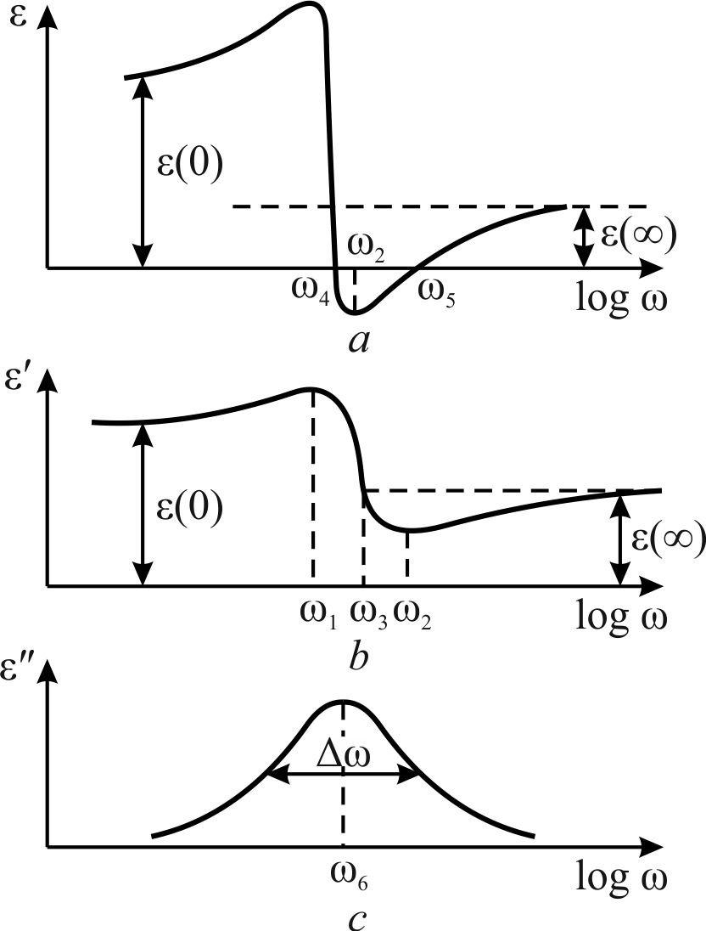
Fig. 4.9. Frequency dependence of permittivity (a, b) and loss factor (c) for resonant polarization at different parameters of equivalent oscillator

The frequencies that define the position of ε'(ω) maximum and minimum, it can be obtained the formula ω_{1,2} = ω₀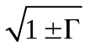. When damping is small (Г << 1), the approximation ω_{1,2} = ω₀(1 ± Г/2) is fair. The maximum and minimum values of permittivity are observed at frequencies ω₁ and ω₂ and respectively equal

ε_{max} = ε(∞) + 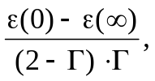 ε_{min} = ε(∞) − 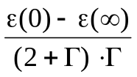 .

Dielectric contribution from quasi-elastic polarization [ε(0) − ε(∞)] vanishes, when frequency equals to ω₀ (intrinsic frequency of oscillator). In Fig. 4.9 this frequency is indicated as ω₃ = ω₀. It may be, that in a certain frequency range ω₄ < ω < ω₅ the ε′(ω) < 0; this corresponds to big dielectric strength of oscillator and its low damping.
Frequency dependence of losses (ε") in the range of dispersion is characterized by a maximum at the frequency ω = ω₆. If the damping is small, in the vicinity of the resonance frequencies it is possible to assign ω₆ ≈ ω₀ ≈ ω₃.
Spectral studies usually give the loss factor frequency dependence: ε"(ω). The half-width of absorption line is defined by the difference in frequencies at the level of ε"/2. With small damping factor Г, loss factor maximum is ε_{max} ≈ [ε(0) − ε(∞)]/Г, while the spectral half-width is determined as Δω/ω = Г. The frequency ω₆ (at which this maximum occurs), and the half-width of the curve ε"(ω) make possible to determine the main parameters of oscillator model. However, the above relations are valid only at Г << 1.
In the case of resonant polarization, the loss tangent is not a convenient feature, as it changes sign in accordance with ε′(ω), Fig. 4.8, a: at the points of zeros of this function the tanδ becomes infinite. Therefore, dielectric absorption at the resonance dispersion is usually described by the losses factor ε"(ω). However, in the case when dielectric losses are studied far away from the resonance dispersion (when ω << ω₀), parameter tanδ still may be convenient to describe losses.
At microwaves and millimetre waves, very far from lattice transverse optical phonon mode frequency ω_{TO}, loss tangent linearly increases with frequency:
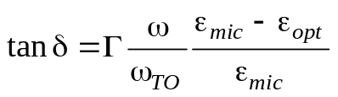. (4.7)
Here Г is relative damping coefficient, ε_{mic} is microwave permittivity (quite below the resonant frequency, when ω << ω_{TO}, while ε(∞) is permittivity quite far above the resonant frequency, when ω/ω_{TO} >> 1, that means the optical permittivity ε_{opt}.
Various scattering processes contribute to tanδ value, their consideration is important for low losses microwave dielectrics research and development. High frequency electrical field acts to neighbouring ions (positive and negative); these ions are displaced in the opposite directions, so the excitation of transverse optical (polarization) oscillations occurs. Power dissipation of these oscillations is caused by different mechanisms.
First of all, any defects in the crystal structure (dislocations, vacancies ion, redundant ions and grain boundary of crystallites) give rise to losses. These defects and other slow-moving ("static") lattice deformations result in optical phonons scattering, and this is so-called two-phonon interaction with static fields of deformations. This is the basic mechanism of microwave losses in real ionic crystals containing structural defects.
However, this is not the only mechanism for high frequency losses: dielectric absorption is possible even in the ideal crystals due to different phonon-to-phonon interactions. These interactions are due to anharmonicity in lattice vibrations. Depending on the crystal structure, symmetry and temperature, the three-phonon or four-phonon processes may prevail. Three-phonon interactions occur when vibrations "cubic anharmonicity" is essential. In this case, two phonons (one of two different optical modes of vibrations) generate a phonon in the third (acoustic) mode or one of the optical phonons is divided into two acoustic phonons. Usually, the low-frequency transverse vibration mode interacts with two high-frequency modes belonging to branches with same polarization.
In the non-polar crystals, the experimental frequency dependence of tanδ usually corresponds to equation (4.7). It is seen that losses increase with the frequency growth, and they are as big as the frequency ω is close to the ω_{TO}. Just this case is typical for high-ε dielectrics. Damping of the lattice mode is weakly dependent on temperature: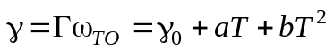. Here, γ₀ describes the two-phonon absorption, while parameters a and b correspond to three and four phonons absorptions mechanisms. Figure 4.10, a shows lattice damping influence to losses in the gigahertz frequencies.
Ionic displace polarization mechanism plays a decisive role for the high frequency dielectrics that have ionic structure. Among these dielectrics there are not only ordinary alkali-haloid cubic structured crystals but many as simple so complex structured dielectric oxides, including paraelectrics, piezoelectrics, ferroelectrics and pyroelectrics, as well as polar structured semiconductors of A^{III}B^{V} and A^{II}B^{VI} groups.

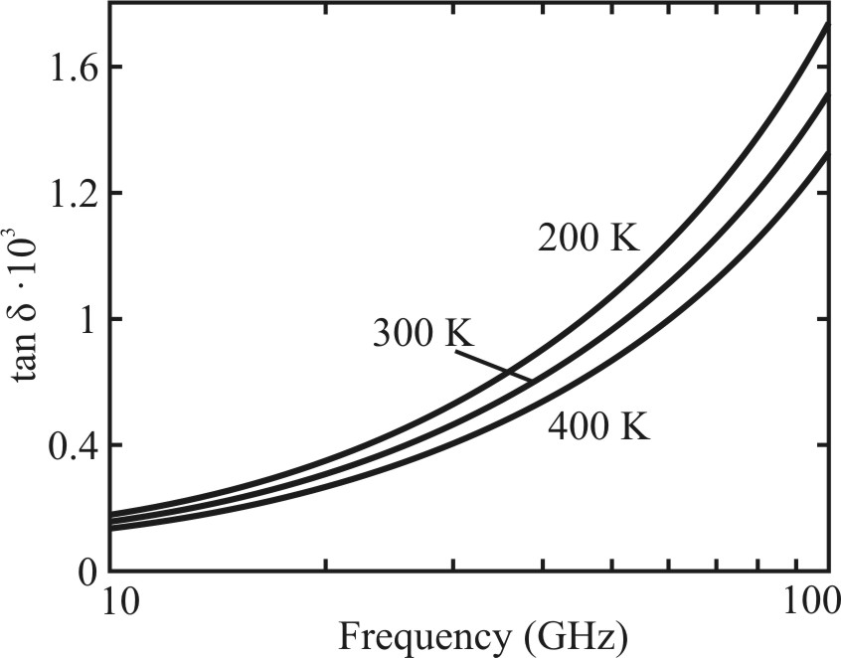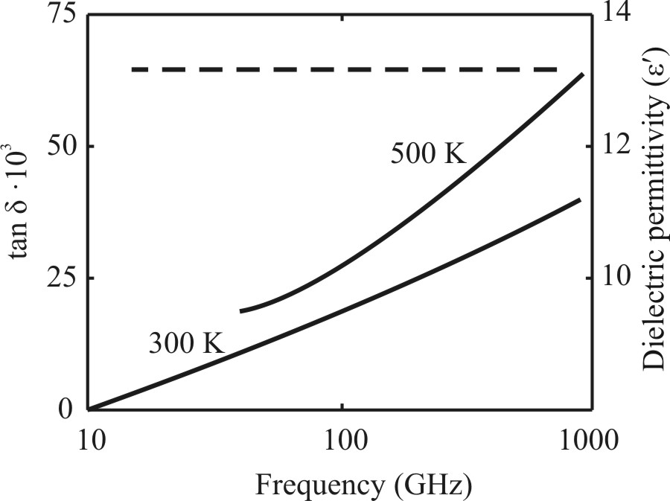
a b
Fig. 4.10. Loss tangent frequency dependence: a – low-frequency tail from lattice loss maximum;
b – impact of quasi-Debye mechanism in polar crystal GaAs (dashed line is permittivity)

Microwave dielectric losses in polar crystals. Among ionic compounds, there are some crystals (ZnO, Bi₁₂SiO₂₀, AlN, BN, etc.) which losses are unexpectedly big that cannot be explained by any of simple loss mechanisms. These dielectrics have practically no conductivity, and a few probability of impurities relaxation, as well as they have too high frequency of the lattice resonance ω_{TO} in order it might have a noticeable affect to the microwave losses.
Sillenites (Bi₁₂GeO₂₀ and similar crystals) have essentially increased microwave losses that shows heightened permittivity (ε ≈ 40), and nitrides (AlN, BN, and others) in which permittivity has usual value for ionic compounds (ε < 10), as well as semiconductors of A^{III}B^{V} and A^{II}B^{VI} groups. One of example is the gallium arsenide in which the influence to microwave loss from the conductivity is very small, but one can see a significant growth of losses with microwave frequency. It is supposed that this increase is the manifestation of internal polarity mechanism of absorption at the millimetric and submillimetric waves. Due to the piezoelectric effect, in the GaAs, for example, a relaxation process arises that is conditioned by the interaction of acoustical and optical phonons modes. This electromechanical coupling results in the “leakage” of electric energy from excited by the electrical field optical phonons to the "heat reservoir" of the acoustical phonons. This is a reason why in gallium arsenide the losses increase with growing frequency. This result is unexpected from the Born theory of far-infrared ionic polarization. Really, the only low-frequency tail from the loss maximum should be observed at the gigahertz region as it is seen.
Semiconductors of A^{III}B^{V} or A^{II}B^{VI} types are polar crystals: A^{III}B^{V} crystals are piezoelectrics while A^{II}B^{VI} crystals furthermore are pyroelecrics. Peculiarities in GaAs frequency and temperature dependences of losses are given by the fast relaxation polarization (quasi-Debye mechanism). In these non-centre symmetric (polar) materials microwave loss factor governs by the very high-frequency mechanism of losses that theoretically is described as the quasi-Debye losses. Frequency and temperature dependences of these losses (Fig. 4.10) are formed by the fast relaxation polarization mechanism; at the condition when ωτ < 1:

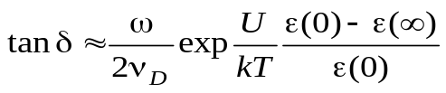,

where ν_{D} is Debye frequency, k_{B} is Boltzmann constant, U is potential barrier. In this case, the loss factor increases as with frequency so with temperature. Nevertheless, the acousto-optical interaction has almost no effect on the magnitude of the microwave dielectric constant, so practically no dependence of ε_{mic}(ω) is observed. Therefore, semiconductors can be used as waveguides and resonant microwave components at centimetric (GaAs) and millimetric (Si) waves.
In the non-polar crystals experimental frequency dependence of tanδ usually corresponds to equation (4.5). It is seen that losses increase with the frequency growth, and they are as big as measurement frequency ω is close to lattice vibration frequency ω_{TO}. Just this case is typical for high-ε dielectrics. This should be considered when designing microwave integrated devices.

4.5. Dielectric spectroscopy

Dispersion of the permittivity has in mind its dependence on the frequency of electrical field: ε = ε(ω). The term is borrowed from optics, where the frequency dependence of the refractive index n = n(ω) is called as a dispersion. In solid-state physics, the dispersion is usually used for of quasi-particle energy (W = ħω) dependence on the quasi-momentum (p = ħk). In the optical and infrared spectrum the dependence of W(p) is reduced to the waves ω(k) dependence, which express wave’s phase velocity on its frequency dependence that corresponds to the ε(ω,k), in other words, the frequency dependence of dielectric constant with taking into account spatial dispersion.
An important property of the dielectric dispersion should be considered as the execution of the Kramers-Kronig relations linking the frequency dependence of the real and imaginary parts of complex permittivity ε∗(ω) = ε′(ω) − iε″(ω):
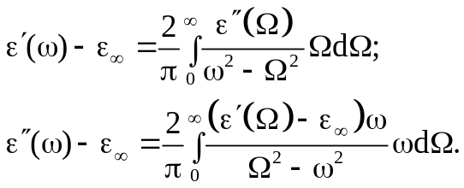 (4.8)

These relationships allow calculate frequency dependence of absorption ε″(Ω) from known frequency dependence of the dielectric constant ε′(ω). In contrast, using frequency dependence of ε′(Ω) by analytics (or by numerical methods with computer) it is possible to determine the frequency dependence of loss coefficient ε″(Ω).
Kramers-Kronig relations are universal to describe the phenomenon of ε-dispersion and can not only control the experimental results, but also to obtain important forecasts as to dielectric losses. For example, using (4.8) it is possible to calculate the static permittivity

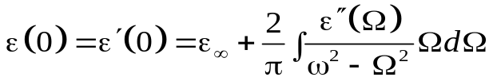

Other complex parameters, such as optical refractive index or complex coefficient of electromagnetic waves propagation in the microwave technique can be also expressed in terms of complex value ε∗(ω).
In the low-symmetry crystals, along main crystallographic directions, one can find different dependences for tensor ε_{k}∗(ω) components, which form the dielectric spectrum. Dielectric spectra investigation is one of important methods for dielectrics physical properties investigation. The frequency dependence of ε_{k}∗(ω) enables to make qualitative judgements about physical nature of dielectric polarization and losses in a particular matter. In addition, it is possible to obtain quantitative data on characteristic frequencies (Ω_{k}) and dielectric contributions Δε_{k} = [ε(0) – ε(∞)]_{k} of correspondent mechanisms of polarization. The study of dielectric spectra in temperature range that is, the experimental characteristics of ε∗(ω,Т), determine temperature dependences of specific frequencies (relaxation times) and other parameters of various polarization mechanisms. In some cases, considerable interest is the study of electrical field influence on the properties of dielectric, so a complex set of ε∗(ω, Т, Е) dependences might be established.
To realize a detailed study of the dielectric spectrum, it is necessary to perform dielectric measurements over a very wide frequency range. This range includes not only low-frequency interval (10^{–3}...10⁸ Hz), but also microwave (3∙10⁸…10¹¹ Hz), submillimeter (10¹¹…10¹² Hz) and far infrared (10¹²…10¹⁴ Hz) frequency bands. As permittivity is a second-rank tensor, the frequency dependence of dielectric constant components can be very complicated, especially for ferroelectrics and other polar crystals of order-disorder type. The reason is the large anisotropy of dielectric constant: the main components of the permittivity tensor ε₁, ε₂ and ε₃ may be quite different, and they vary by hundreds of times. In addition, the contributions to dielectric constant tensor can be produced by many different mechanisms of polarization.

As an example, Rochelle Salt dielectric spectrum is shown in Fig. 4.11. In this type of ferroelectrics there are two main frequency intervals of dielectric permittivity dispersion: domain walls relaxation in the polar phase and dipole relaxations in all phases. Rochelle Salt is characterised by two Curie points where at low frequencies the ε₁ has temperature maxims of about 5000 (–18 ºC and +24 ºC), but these maxims at microwaves decreases only to ε_{1max} ≈ 200.
Sharp maxims of ε₁′(ν) in Fig. 4.11, a in the frequency interval of 10⁴…10⁵ Hz means piezoelectric resonances that are accompanied by a fluent ε₁′-decrease near frequency of 10⁶ Hz. This decrease is explained by domain relaxation process that follows electromechanical resonances. In the microwaves, the Rochelle Salt shows ε₁′-dispersion which is accompanied with ε″₁ broad maximum; this dispersion characterizes structural dipoles relaxation which can be described by Debye equation (3.4). In two others main crystallographic directions (for ε₂ and ε₃) ferroelectricity in the Rochelle Salt is absent, and no temperature anomalies for ε₂ and ε₃ exists.

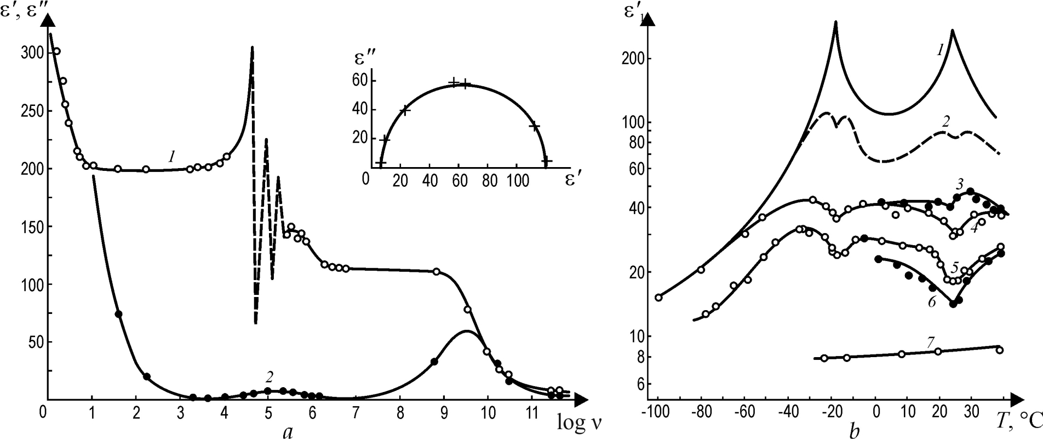
Fig. 4.11. Rochelle Salt microwave study: a – ε′₁ and ε″₁ frequency dependence at 18^{о} С;
b – ε′₁ temperature dependence at frequencies (in GHz): 1 – 0.8; 2 – 5.1; 3 – 8.4; 4 – 10.2;
5 – 20.5; 6 – 27; 7 – 250.

Microwave ε₁-dispersion in the Rochelle Salt is observed in all phases (in the paraelectric phase above 24 ºC, in the ferroelectric phase between –18 ºC and +24 ºC, and in the antiferroelectric phase below –18 ºC, Fig. 3.5, b.
To describe ε*(ω,T) dependence in the paraelectric phase using Debye equation one need substitute τ = τ₀/(T – θ) and ε(0) – ε(∞) = С/(Т – θ). Experiment shows that in paraelectric phase C = 1700 K, θ = 291 K and τ₀ = 3.2⋅10^{–10} s/K. By the analogy this calculations can be done in all phases of the Rochelle Salt.
Dielectric dispersion is characterized by various parameters which are determined from the experimental data. As the dispersion frequency is called a frequency at which a maximum of ε″(ω) is observed. The width of the spectrum is determined by the difference between frequencies at which this maximum is reduced by half. As the depth of dispersion, the relative contribution from a given polarization mechanism to the ε(0)-value can be called, i.e., this is 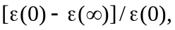where 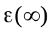is the high-frequency dielectric constant.

The purpose of dielectric spectroscopy is experimental detection of different mechanisms polarization, and separation of their deposits to permittivity.

However, sometimes experimental studies of dielectrics can not be added up to certain parameters. This occurs due to unavoidable errors in ε′ and ε′′ measurements. Besides, according to many experimental data, studied permittivity and losses vary with frequency in a wide frequency range. This may mean that the polarization in the real dielectrics leads to much more diffuse ("smearing") spectra that would be expected from the above discussed models of ε∗(ω) dispersion. In addition, there may be cases, when reliable observation of the ε-dispersion over a range of frequencies is still not clearly identify exactly which model – resonance or relaxation – it needs to use. This uncertainty can be caused not only by the features of polarization. Sometimes relaxation and resonance (with high attenuation) spectra may be so close, that, in the dispersion region, the relative measurement error of ε' and ε" of about 10...20% already troubles the choice in favour of a particular model of polarization.
In many cases, to approach theory to experiment can be done at the expense of assumptions about the distribution in a frequency range the proper frequencies of relaxation oscillators (representing relaxation processes) or dispersion oscillators (describing the resonant processes). It is obvious that any distribution leads to the expansion of dispersion area, i.e., characterizes the diffuse spectra. In these spectra parameters, that characterizing the dispersion, vary significantly: spectral width increases, maximum dielectric losses decreases, and even central frequency of dispersion may be changed also.
Both theoretical models – Debye type dispersion and Lorentz type dispersion – that respectively lead to the relaxation and resonant dispersion, can be converted to describe the fuzzy dielectric spectra.

4.6. Diffuse relaxation spectrum

The main parameters of the relaxation spectrum were described by equations (3.2…3.4). For future analysis it is better to modify Debye formula by typing a "normalized" notation:
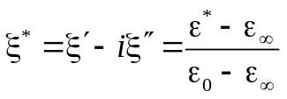.
Apparently, Debye equation in this case becomes simpler:
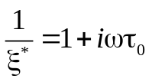.
Separating real and imaginary parts of ξ* and introducing the notation ωτ = z, for the real and imaginary parts, it possible to obtain:
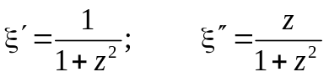 (4.9)
Dispersion frequency Ω = 1/τ₀, by definition, is characterized by the maximum value of absorption (loss coefficient). From equation (4.9) it follows that the condition of ξ″(z)-maximum is the expressions: дξ″/дz = 0 and д²ξ″/дz² < 0, that corresponds to z = 1 while the normalized maximum of loss factor is ξ″_{max} = 0.5.
The width of the spectrum is characterized by a parameter Δω/Ω, where Δω = ω₂ – ω₁. Frequencies ω₂ and ω₁ are determined at ξ″ = 0.25 (ξ″_{max} = 0.5). From the equation (4.9) it follows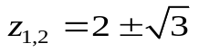. Hence, the width of the Debye spectrum is 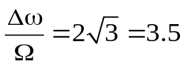.
Describing relaxation spectrum by Debye equation shows an interesting feature: in the rectangular coordinates, this is the equation of a circle:
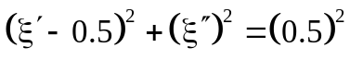 . (4.10)
This fact was first noted in works of C. Cole and R. Cole. The Cole-Cole diagrams are shown in Fig. 4.12) as for dielectric contribution in normalized coordinates (ξ′ and ξ″) so for usual coordinates (ε' and ε"). When ε*-dispersion is sufficiently described by Debye equation, the experimental data really "falls" on the semicircle. If the research is carried out not around the desired frequency range, the chart Cole-Cole may be used for correspondent approximation.
However, in many cases, measurements indicates that the experimental data do not correspond to the ε-dispersion shown in Fig. 4.12, a and b, which are the semicircles (i.e., to simple Debye equation). This means that in a given dielectric there are polar complexes which have different relaxation times. It is obvious, that in such cases the dispersion spectra should be wider (more diffuse) than in the case when relaxation time for all particles is the same.
Frequency broadening of the dispersion spectrum can also arise due to the interaction of relaxing particles.

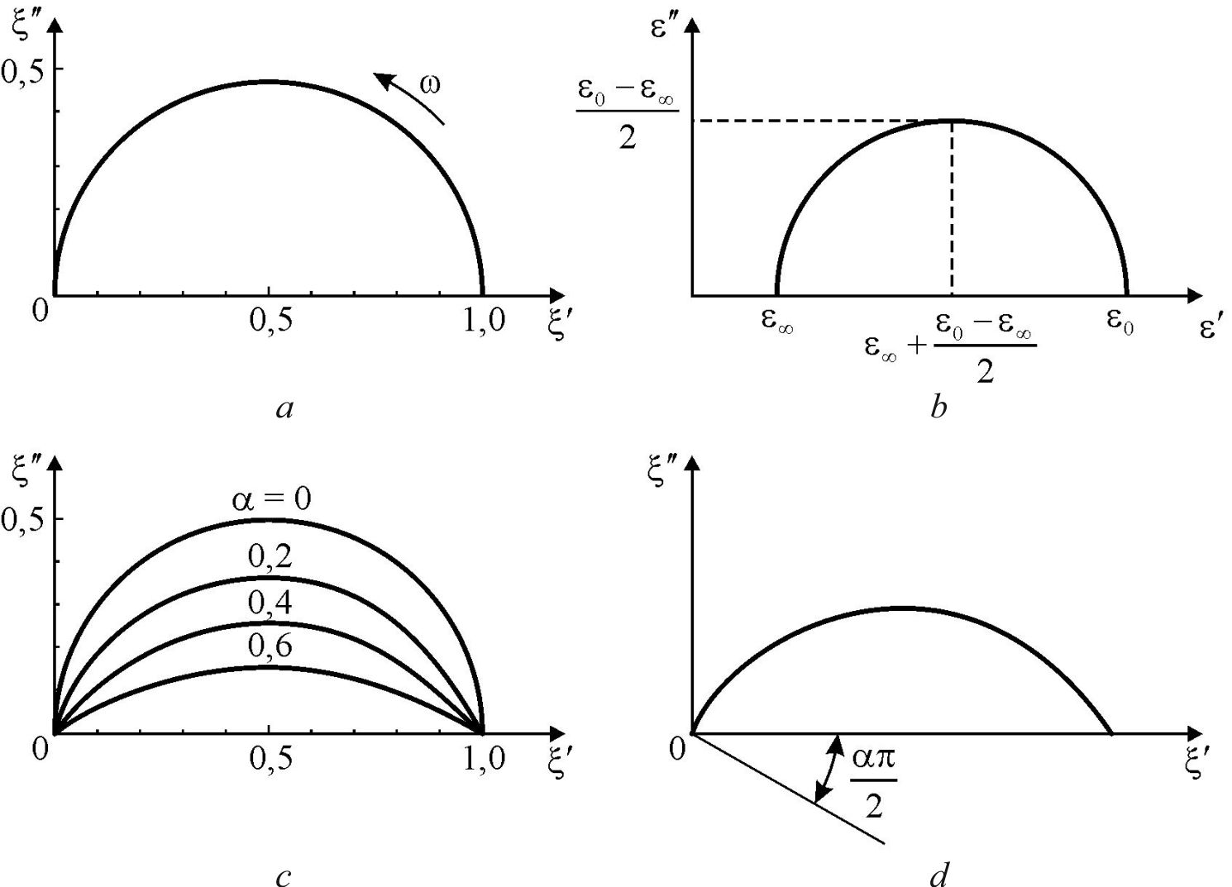

Fig. 4.12. Cole-Cole diagrams for: a – Debye equation in normalized coordinates;
b – Debye equation in normal coordinates; c – circular arcs describing Cole-Cole equation under different α; d – definition of the parameter α

To describe the ε*-dispersion in those dielectrics in which the spectrum is diffuse, C. Cole and R. Cole proposed an empirical equation which is incorporated herein by the normalized values:
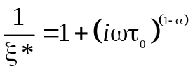, (4.11)
where τ₀ is average relaxation time and α is a parameter characterizing the distribution of relaxation times (can be found from the experimental data, as in Fig. 4.12, d).
From formulas (4.9) and (4.10) comparison, it is clear that case of α = 0 corresponds to the Debye equation. Separating the real and imaginary part of ξ* in the equation (4.11), it can be shown that dispersion spectrum of permittivity, described by the equation Cole-Cole, is much more degraded as compared with the spectrum described by the Debye equation. Absorption maximum in this case is lower than in the case of Debye spectrum:
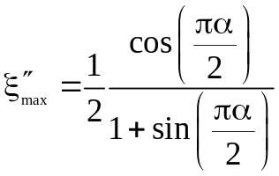.
Relative width Δω/Ω of absorption maximum is estimated by the frequency difference ω₁ – ω₂ at which ξ″_{max} decreases two times. For specific assessment it can be put α = 0.5. Using the above formula, it is possible to calculate the relative spectral width of the Cole-Cole is Δω/Ω ≈ 27, this is almost 8 times larger than the width in this case of the Debye spectrum.
On the plane ξ′ – iξ″ the Cole-Cole equation as well as the Debye equation are described by a semicircle, but its centre is shifted downward along ξ′ by amount 0,5tan(πα/2), and the radius of semi-circle is defined by the expression R = 0,5cos⁻¹(πα/2). In the case of α = 0, the centre of circle is not shifted and R = 0.5, i.e., the dispersion becomes as Debye type, Fig. 4.12, a. From Cole-Cole correlations, it follows that parameter α specifies the angle between the axis ξ' and the radius of the circle, as shown in Fig. 4.12, d. Distribution parameter α is the empirical one, and it has no definite microscopic grounds. Nevertheless, the relaxation times are grouped symmetrically around mean time.
Cole-Cole method of diffuse spectra analysis is very often used by experimenters, as it allows control experimental data accuracy. As in the case of Debye equation, the semicircle arc allows extrapolate ξ″ and ξ′ experimental data to the frequency range in which measurements, for various reasons, is difficult to perform. The disadvantage of Cole-Cole equation is the fact that it was not derived from any physical model, which assumes a particular form of the distribution of relaxation oscillators for frequency.
There are well known and used others – both empirical and modelling –methods how to solve the problem of relaxation oscillators distribution the range of ε-dispersion. For example, in the distribution proposed by R. Fuoss and J.Kirkwood, it is assumed that the ε″_{max} decrease in the diffused relaxation spectrum can be described by a certain parameter λ:
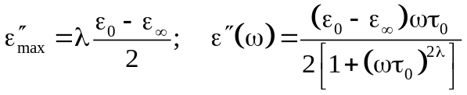. (4.12)
Distribution parameter 0 < λ < 1 is a measure of the width of the spectrum, and it can be found from the experiment from the slope of line
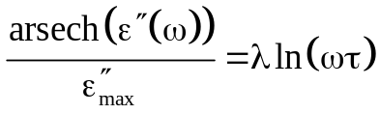.
Indeed, in some dielectrics with relaxation polarization, the dependence of the logarithm of frequency the area-secant is close to a straight line. But in other dielectrics thus treated experimental data deviate from a straight line. There are some ways of the dependence correction, but such mathematical operations are not interpreted by any particular physical model.
In other studies it was suggested the interaction of relaxation oscillators that also can lead to the diffuse dispersion spectrum, which is described by the equation
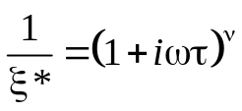 (4.13)
where parameter, that accounts the dipoles interaction, is 0 < ν < 1. When ν = 1, the formula (4.13) turn into Debye equation; at ν = 0,5 obtained dependence coincides in the complex plane ξ′ – iξ″ to the equation of the lemniscates; in general, when ν < 1, the chart has the form of a lemniscate-like arcs, Fig. 4.13.
Unlike Cole-Cole and Fuoss-Kirkwood distributions of relaxation oscillators, the frequency peaks of ξ″ shift toward higher frequency, and look as non-symmetric ones (this is evident from graphs shown in Fig. 4.13). Typically, this method of experimental data processing of dielectric dispersion is used for the polar polymers investigation.

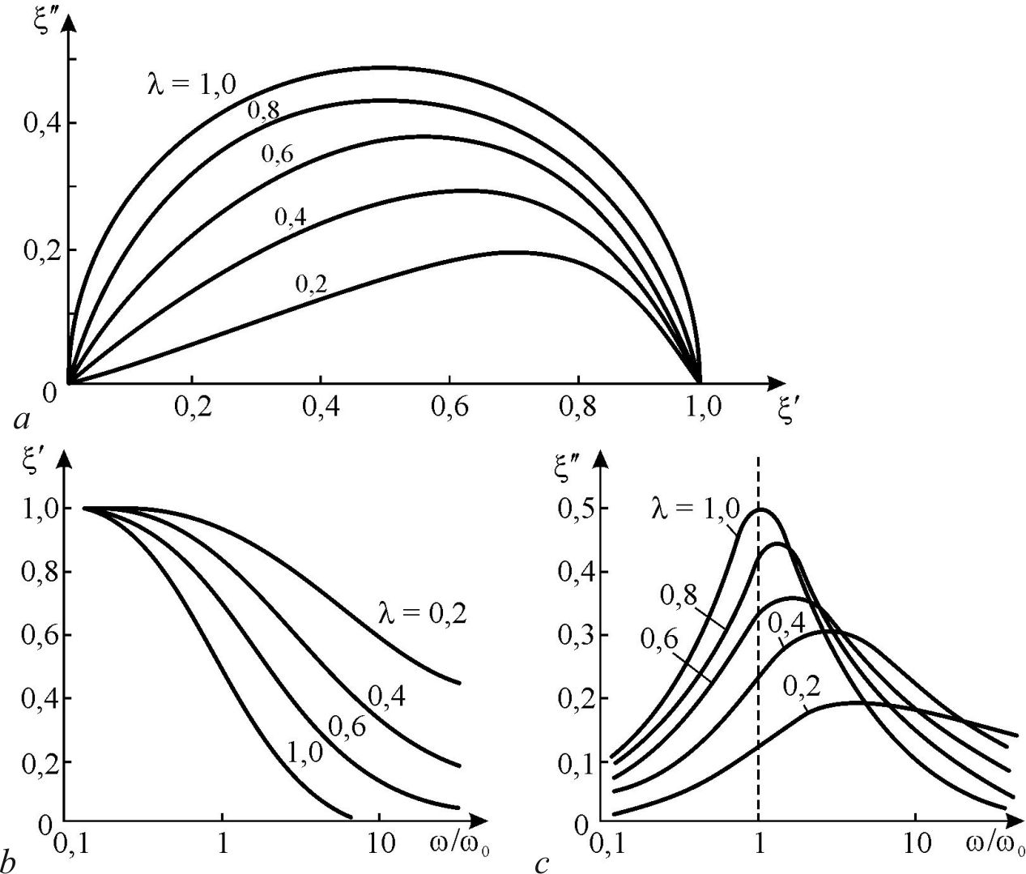

Fig. 4.13. Chart in complex plane in the case of lemniscate type of relaxation oscillators distribution (a), and the frequency dependences of ξ′ (a) and ξ" (c)

Relatively simple expressions (4.11), (4.12) and (4.13) can be successfully used for phenomenological description of diffuse spectra of ε-dispersion in the dielectrics of different structures. Distribution parameters α, λ or ν are determined rather simply by the known guidelines. However, proposed rather simple expressions lead to very complex functions of relaxation oscillator distribution, which can be found by the Fourier integral. The complexity of these functions does not follow from any microscopic models. At the same time, the model concepts elaborated for the ε-dispersion study in a given dielectric looks as very important.
For this reason, the following provides simple model for relaxation oscillators distribution that allow evaluate frequency allocation of dispersion interval from the experimental data. Comparison the introduced distribution parameter a with empirical distribution parameters α и ν from equations (4.11) and (4.13), allows to determine the width of the relaxation times distribution for these empirical treatments of experimental data.
Proposed distribution is not use the relaxation time τ but characteristic frequency Ω which is more convenient from a methodological point of view, since the experiment is provided with frequency characteristics investigation.
The distribution function of relaxation oscillators in a frequency interval is a dimensionless, i.e., the function у(Ω) characterizes the "normalized density" of distribution. This assumption leads to the following expressions for ε*(ω) and for distribution function normalization:
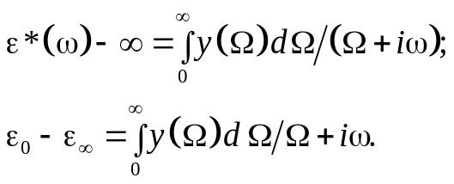 (4.14)
These expressions generalize the Debye dispersion formula to the case of relaxation oscillators distribution in the frequency interval in accordance with the function у(Ω). In the case of specific calculations, one should justify the choices of this function.
The natural assumption is the normal distribution of relaxation oscillators (Gaussian function), but it leads to a complex solution of integrals (4.14). A fairly good approximation of this problem is the uniform distribution of relaxation oscillators in the frequency range from Ω₁ > 0 to Ω₂ with the distribution parameter а = Ω₂/Ω₁ (at that, the Gaussian "bell" is simulated by the "rectangle").
This case is qualitatively close to the Cole-Cole spectra, but enables easy finding the distribution of relaxation oscillators in a frequency range from the experimental data. In the integrals (4.14) it needs to put у(Ω) = a in the frequency range of Ω₁ ≤ Ω ≤ Ω₂, and у(Ω) = 0 outside of this interval. The following form of the distribution function is determined from the normalization integral:
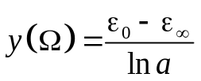.
Evaluation of the integral for ε*(ω) by substituting this distribution function leads to the following expression for the "normalized" values of the real and imaginary parts of dielectric constant:

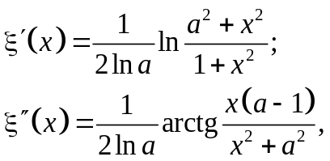 (4.15)

where х = Ω /ω is the normalized frequency and a = Ω₂/Ω₁ is distribution parameter.
The maximum of normalized loss ξ″_{max} can be found from condition дξ″/дх = 0, and this maximum is located at the normalized frequency х_{max} = а^{1/2}. With increasing of the distribution parameter, the ξ″_{max} systematically decreases, Fig. 4.14) in accordance with expression:
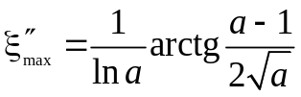.

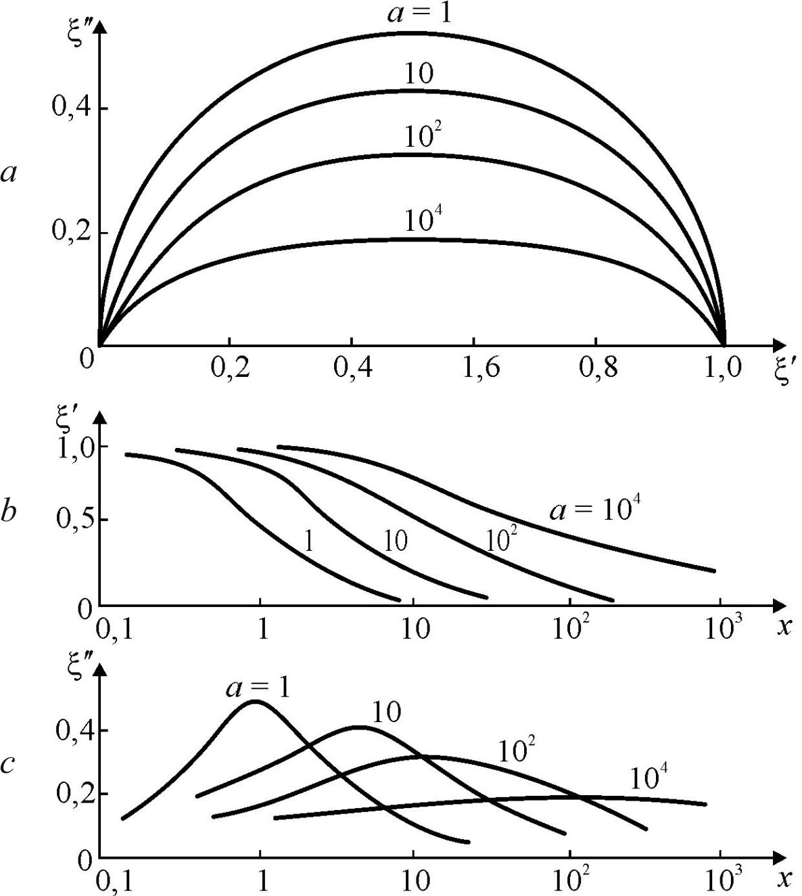

Fig. 4.14. Diagrams ξ" – ξ′ on the complex plane (a) and the frequency dependence
of real ξ′ (b) and imaginary ξ" (c) parts of normalized permittivity

This expression, when compared with corresponding relations for ξ″_{max} from empirical distributions (4.11) and (4.12), allows analytically relate the Cole-Cole and Fuoss-Kirkwood distribution parameters α and λ with modelling distribution parameter a in the equation (4.15). Therefore, if it is assumed that the value of ξ″_{max} is the most important characteristic of a diffuse spectrum. From known data of diffuse spectra processing by empirical methods, it will be possible to judge the frequency range of the distribution of relaxation oscillators (supposing their uniform distribution in the range of frequencies).
The dependence ξ″(ξ') on the complex plane is described by equations (4.15), which are characterized by ellipse-like arcs (Fig. 4.14). It should be noted, however, that the measurement error (which in determining by losses definition) only in rare cases may be lower than 5%. So in practice one can not judge which arcs exactly is obtained in the diagram ξ″–ξ': the Cole-Cole circle arc or the ellipse-like arcs from equation (4.15). As the analysis of dispersion equations (4.15) shows, even at essential width of relaxation oscillators distribution (a = 10) the value of ξ″_{max} (which in the case of the Debye equation is equal to 0.5) is reduced to only to 0.42.
Therefore, when the measurement error is about 10%, the distribution parameter can be found up with accuracy of the order. To estimate the distribution parameter with an error of ~30%, it is necessary to reduce the measurement error down to 2%, which usually is quite difficult. It follows that if the error of losses measurement is about 10%, the resulting relaxation spectrum in coordinates ξ″–ξ' is characterized by a semicircle (i.e., it looks like being described by the Debye equation). Therefore, it does not mean that spectrum corresponds to the relaxation process with a single relaxation time. To ensure data in such treatments of dielectric dispersion, which is characterized by almost one dielectric relaxation time, the measurement accuracy must be very high, which is currently possible only when using a unique measuring systems.
Thus, the relaxation spectrum of dielectric constant dispersion is not very sensitive to the distribution or interaction of relaxation oscillators, which explains the almost universal possibility of Debye equation application.

4.7. Diffuse resonant spectrum

The frequency dependence of permittivity in dielectrics in the case of resonant polarization is usually described by single damped oscillator, that is, using Drude-Lorentz equation (4.6). While normalized frequency х = ω/ω₀ and normalized permittivity ξ* introducing for Lorentz oscillator, after real and imaginary parts separating, it is possible to obtain:

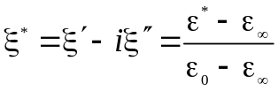, 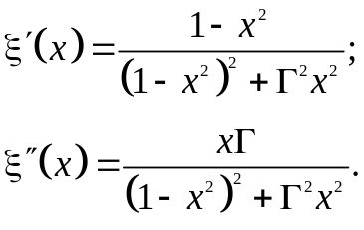
Minimum and maximum of real part of permittivity: ξ′_{1,2}(х) = [Г(2 ± Г)^{–1} are observed in the normalized frequencies х_{1,2}² = 1 ± Г respectively. When attenuation is large (Г > 1) the maximum of ξ′(х) can not be observed. However, the minimum of ξ′(х) does not vanish at any values of attenuation Г, and just this is used to distinguish high attenuation resonance spectrum from the relaxation spectrum,.
The maximum of normalized loss factor ξ"(x) takes place at normalized frequency х₃:
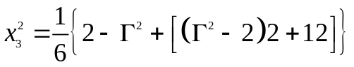. (4.17)
So the only when value of Г < 1 it is possible to assume (approximately) that х₃ defines the frequency of modelling oscillator. Correspondent diagram in a complex plane at various relative attenuation Г is shown in Fig. 4.15.
The form of ξ′ – ξ″ curves is significantly different from the Cole-Cole arcs, because in the case of resonance spectrum in any Г the area with ξ′(ω) < 0 is observed. With attenuation increasing, as the dependences ξ′(ω) so the ξ"(ω) maxims become blurred, at that these maxims are significantly shifted to lower frequencies
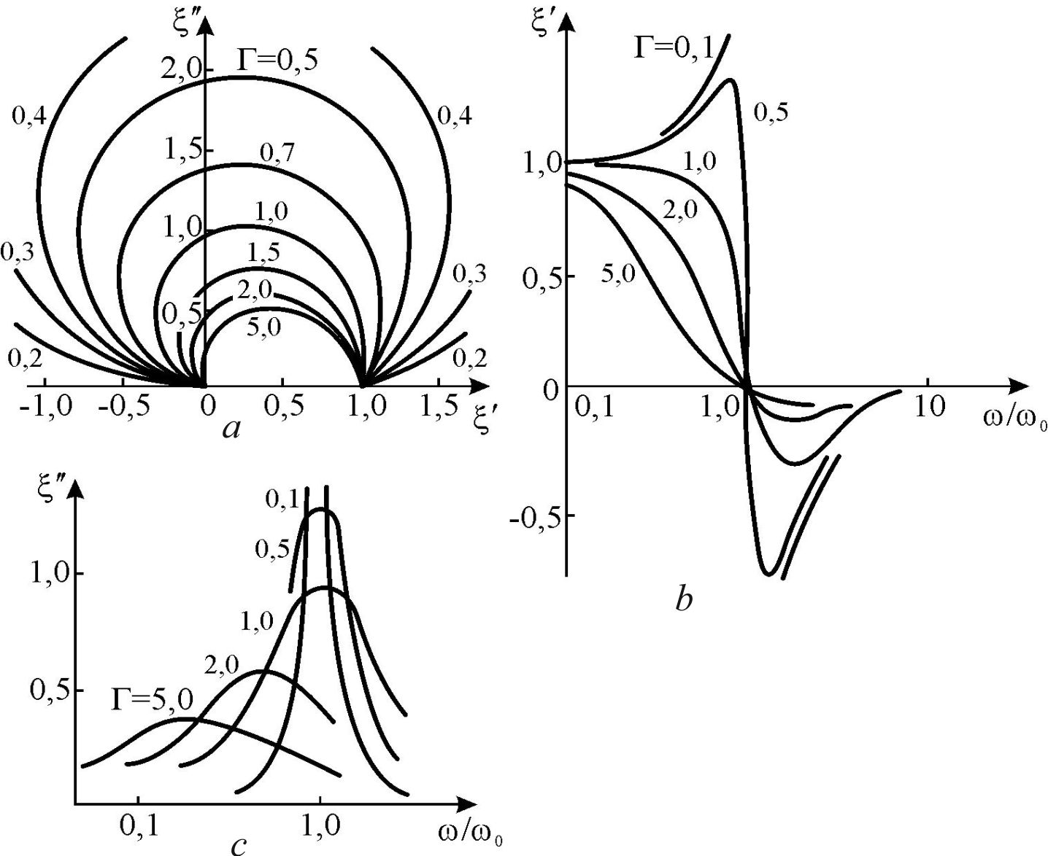

Fig. 4.15. Chart ξ" ​​– ξ′ for different values of oscillator` damping Г (a),
and frequency dependence of ξ′ (b) and ξ" (c)

In some studies of dielectrics it is possible to see large relative attenuation. The critical value of damping is considered to be Г = 2, as it is shown in Fig. 4.15, b. Only at Г < 2 the quasi-elastic system, derived by an external force from its equilibrium position, can oscillate with the natural frequency ω₀. If attenuation Г > 2, the oscillator is called as "over-damped" one, as the equilibrium state of the system in this case is restored aperiodically.

Various value of relative attenuation significantly impacts on the nature of dispersion spectrum, Fig. 4.15. The maximum on the curve ε′(ω), as well as on curve ξ′(ω), is observed in the beginning of ε-dispersion, at the frequency 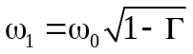. As far as the attenuation increases, this maximum becomes smoothed, and at Г = 1 it disappears. However, the minimum on the curve ε′(ω) (as well as on curve ξ′(ω)), is retained even in the case of very high attenuation. The frequency of this minimum is 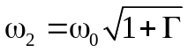, and the disappearance of this minimum is possible only if Г→ ∞. Thus, it can be assumed that minimum in the ε′(ω) frequency dependence is a fundamental feature of the resonant dispersion, and sets it apart from the relaxation dispersion.
An important objective of the ε-dispersion study, as well as experimental data mathematical processing, is to determine the basic parameters of dispersion equation (4.6), which are ε′(0), ε′(∞), ω₀ и Г. The first two parameters are determined from the ε′(ω) dependence at such frequencies, when dielectric losses (absorption) are smallish, and the error in ε′ determination is acceptable. However, while determining of ω₀ and Г from the experimental data one may encounter difficulties.
In the case of small damping, the ω₀ and Г can be accurately found using above given formulas. To determine ω₀ and Г for any value of attenuation, including the case of over-damped oscillator, several methods might be used.
1. The resonant frequency of the oscillator ω₀ can be found from the ε′(ω) dispersion, if one use the fact that far above the range of dispersion ε′(ω) = ε′(∞). If this method looks difficult (in case of a complex many-oscillator spectrum) then ω₀ may be found from the frequency maximum of effective conductivity σ = ε₀ε″ω that is located exactly at frequency ω₀.
2. The relative attenuation Г can also be determined from the minimum of ε′(ω) at frequency ω₂: Г = (ω₂/ω₀) – 1. If this method is inconvenient for some reason (it leads to errors for over-damped oscillator), the value of Г can be found by solving the equation (4.17). In this case х₃ = ω₃/ω₀, where ω₀ can be found by the σ_{max}(ω) location and ω₃ corresponds to location of maximum ε"(ω).
Discussing various ways of fundamental information obtaining from dielectric dispersion spectra, it should be noted the relative complexity of data processing, especially for resonant spectra.

Relaxation spectra are usually observed at lower frequencies. For their study, it is usually sufficient to provide measurements at frequencies up to 10¹⁰ Hz. In this frequency range the ε′(ω) and ε"(ω)) is determined directly without any complicated processing of information (for example, using Kramers-Kronig relation, which is typically used in studies of dielectrics in the infrared region).
Resonant dispersion is usually observed in infrared wavelength range or at microwaves, when it is necessary to perform, sometimes, rather complicated preliminary calculations before you get ε*(ω). Of particular difficulty are such dielectrics, which dispersion spectra can be represented by a model of the oscillators with high attenuation. In this connection it is interesting to note some experimental features that characterize the dispersion spectra with high attenuation of equivalent oscillator.

1. High attenuation effect is seen on the curve ε′(ω) as the absence of ε′ increase in the initial dispersion region, Fig. 4.15, b.
2. A similar condition can be obtained for the case when the experiment gives directly any parameter associated with |ε*| (microwave measurements methods). In this case it can be shown that the maximum of |ε*|(ω) should be absent at the condition of Г ≥ {(2ε₀[ε(0) – ε(∞)]}^{–1/2}, that is in higher value of relative attenuation in the case of ε′(ω) dependence. If assume that ε(0) >> ε(∞), which is typical for polar dielectrics and ferroelectrics, the above condition is simplified: 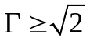.
3. In the infrared reflection spectra, as well as using studies of dielectrics by quasi-optical methods in the submillimetric wavelength range, the increase of ε′(ω) and ε"(ω) in the initial region of the resonant dispersion should lead to the corresponding increase in the reflection coefficient R. Approximately (at low attenuation) this relationship is expressed by the formula
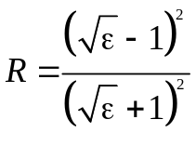,
from which it is seen that at ω → ω₀ and corresponding increase of ε′(ω) the value of R(ω) increases in the initial region of the dispersion. However, the higher attenuation, the weaker manifestation of resonance properties in R(ω) dependence. At the certain value of Г, in the initial region of dispersion, the increase R(ω) will be absent. When ε(0) >> ε(∞) this criterion is reduced to a simple inequality Г ≥ 2, which coincides with the definition of the over-damped oscillator.
Thus, even from direct experiments – from the very form of ε′(ω), |ε*|(ω) or R(ω) spectra – it is possible to judge which model is suitable for the experimental data interpretation. In the case of oscillator model implementation, it is possible to estimate the attenuation of the oscillator.

Degraded (diffuse) resonant dispersion spectra can be observed in solid dielectrics in different frequency intervals. These spectra occur, for example, in the polycrystalline and other inhomogeneous dielectrics. Diffuse resonant dispersive spectra are also observed in ferroelectrics.
Figure 4.16 shows the dielectric spectrum for polarized polycrystalline barium titanate. All three regions of dispersion can be described by degraded resonant dispersion spectra. At the radio-frequency range (section 1), many piezoelectric resonances are observed with the variance of frequency and damping, which are determined by electromechanical properties, geometric shapes, and acoustic coupling of test sample. Permittivity ε^{X} characterizes the dielectric response of mechanically free sample while ε^{x} is permittivity of clamped sample. It should be noted that decrease of permittivity is usually observed while experimental studies of ferroelectrics, pyroelectrics, electrets and other solid dielectrics with pronounced piezoactivity.

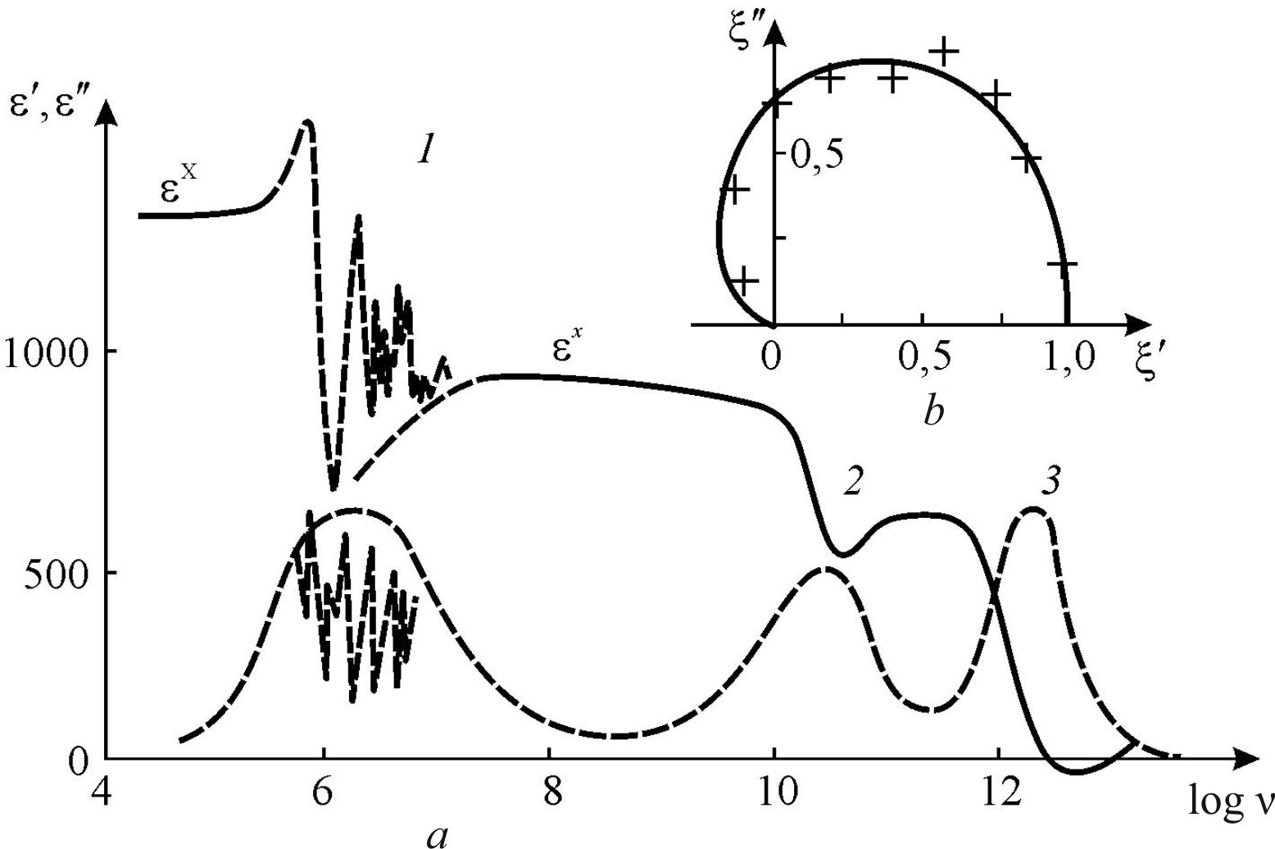
Fig. 4.16. Frequency dependence of ε' and ε" for polycrystalline polarized sample of barium titanate: 1, 2 and 3 are three sections of resonance spectrum, 2 and 3 diffuse. On fragment for second dispersion region diagram ξ"(ξ′) is shown (peculiar to damped resonant dispersion)

The frequency change of permittivity in the vicinity of piezo-resonances can be described by the dispersion equation, but this variance is determined not only by physical processes in dielectrics, but also depends on the contact of sample with the medium and properties of this medium, moreover, the resonant frequency depends on the sample dimensions and shape. In the polycrystalline samples, which typical frequency characteristic are shown in Fig. 4.16, the need of many-oscillator model is obvious: under the certain conditions, a lot of ε' and ε" maxims may combine into a continuous spectrum, so that from the sum of the oscillators, in principle, it is possible to go to their distribution.
Section 2 in Fig. 4.16 characterizes the so-called microwave ε-dispersion in barium titanate. This dispersion is observed in all multidomain ferroelectric materials of this type. The resonant nature of microwave dispersion in ferroelectrics was predicted by C. Kittel. A clear resonant response, however, is difficult to observe because of spectrum blurring. Ferroelectric ceramics is composed of a plurality of crystallites, and each crystallite contains a number of domains (domains can even cross the boundaries of crystallites). In the microwave ε-dispersion a significant contribution to the dielectric constant is due to high polarizability of domain walls. The difference in the characteristic frequencies of oscillators, describing dispersion of domain polarization, can be quite large due to the variety of electrical and mechanical conditions in various micro-regions of samples. Therefore, the ε*(ω) microwave spectrum can be rightly shows the distribution of equivalent oscillators frequencies, characterized by resonance polarization of domain walls.
Finally, the section 3 in Fig. 4.16 is again a blurred resonance spectrum, but at very high frequencies – in the far-infrared (IR) region. And in this case, the spectrum degradation is due to the many-domain structure of samples. In the range of barium titanate IR dispersion at 300 K the dispersion frequency equals 2⋅10¹² Hz, while the relative damping coefficient is Г ≈ 2.5. Obviously, during study of multi-domain samples, a certain average frequency and damping can be established, that is determined by the width of spectrum. In fact, each domain in BaTiO₃ has an anisotropic permittivity: ε_{с} = 80 and ε_{а} = 2000. The observed at microwaves (prior to the IR dispersion) the average permittivity equals ~500.
As it follows from the Liddeyn-Sachs-Teller relation, the frequency of IR-resonances, at which the major contributions of infrared polarization to ε_{с} and ε_{а} are switched off, might vary considerably. Studies of single-domain crystals show that these frequencies are ν_{с} = 5.6⋅10¹² Hz and ν_{а} = 0.4⋅10¹² Hz accordingly. While IR spectra studying, the multidomain sample contains a plurality of randomly a oriented domains, therefore the IR spectra are smeared over the frequency range ν_{а} – ν_{с}. While description of such spectra, it is natural to use the model of a continuous distribution of oscillators which have different frequencies within the frequencies dispersion of the dielectric ellipsoid with principal axes of ε_{с} and ε_{а}.
Due to resonance spectrum degradation, the spectrum distortion looks approximately the same as in the case of damping increasing for the case of single damped oscillator: in the initial region of dispersion the maximum in the ε'(ω) dependence decreases while loss maximum ε"(ω) declines and extended, but the minimum of ε'(ω) in the high frequency part of the spectrum is saved, Fig. 4.16.

Model of uniformly distributed oscillators. To obtain the dispersion equation describing diffuse resonant spectrum of ε*(ω) the dimensionless distribution function oscillators is introduced – in the same way as in the case of the distribution of relaxation oscillators. In addition, similarly selected the condition for the distribution function у(Ω):

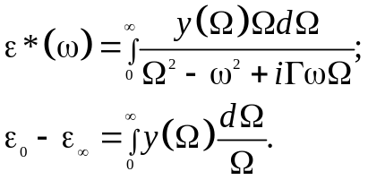 (4.18)

To simplify the problem, it is assumed that the relative damping Г for all oscillators is equal.
In connection with the above examples of fuzzy relaxation spectra, it can be supposed also that the oscillators are distributed uniformly, that is, the function у(Ω) = const in a certain range of frequencies from Ω₁ till Ω₂ with distribution parameter а = Ω₂/Ω₁. This case is actually the summation of many oscillators contributions whose frequencies are uniformly distributed from Ω₁ till Ω₂.
It is obvious that such a model of diffuse is the simplest, but it allows satisfactorily describe the different cases of diffuse resonant spectra. The following are the results of calculations on the assumption of a uniform distribution of such oscillators. Normalization integral and integrals for ε′(ω) and ε″(ω) are:
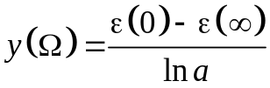, 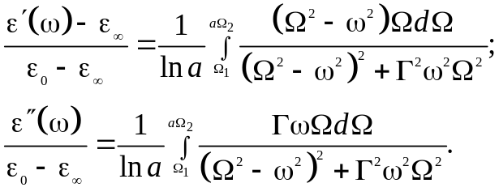 (4.19)
These integrals are calculated by Hermite-Ostrogradskii method, and obtained after integrating expression can be are reduced to the formula ε′(ω) and ε″(ω) of single oscillator, if one put the distribution parameter a = 1.
If use the normalized variables ξ′(х) і ξ″(х), where х = ω/Ω, the results of integrals calculations lead to rather cumbersome expressions. However, studies of the extrema show that the maximum and minimum of the real part of normalized permittivity ξ′(х) are observed at relative frequencies х₁ и х₂ respectively:
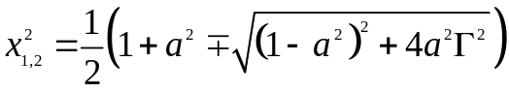. (4.20)
If the distribution parameter a = 1, then these extremes, as it might be expected, correspond to Lorentz equation, and they are х²_{2,1} = 1 ± Г. The difference x₂ – x_{l} that characterizes the width of the diffuse spectrum, in the case of oscillators distribution (4.20) depends not only on their damping Г but on the parameter a.
The frequency, at which maximum of ξ″(х) is observed, can also be found from the equation of dispersion. Figure 4.17, b shows an example of the frequency dependence of the normalized parameters ξ′(х) and ξ″(х) for uniformly distributed oscillators. It can be seen as far as the distribution width increases the spectrum range widens; at that maximum of absorbance decreases while this maximum becomes more blurred.
It is noteworthy that at the point of ξ' = 0 the slope of slanting line to the graph is the same, and it does not depend on the distribution parameter, but depends only on the value of Г. The same phenomenon was observed in the more simple case of one-oscillator model, but with the important difference that the quantity of ξ″_{max} can not be less than 0.5. Therefore, a recommendation is needed how to separate the influence of distribution parameter from attenuation of the oscillator on the width of the spectrum.
Analytical consideration of this question shows that the derivative dξ″/dξ′ does not depend on the parameter a, but is determined only by Г. Indeed, from Fig. 4.17 it follows that the tangent to the diagrams ξ″ (ξ′) at the point ξ′ = 0 have the same slope different distribution parameters a. The greater the slope of tangent, the greater is the Г, which provides a graphical way to determine the value of Г from the diagram. After such a determination of Г, it is possible to find the distribution parameter a.

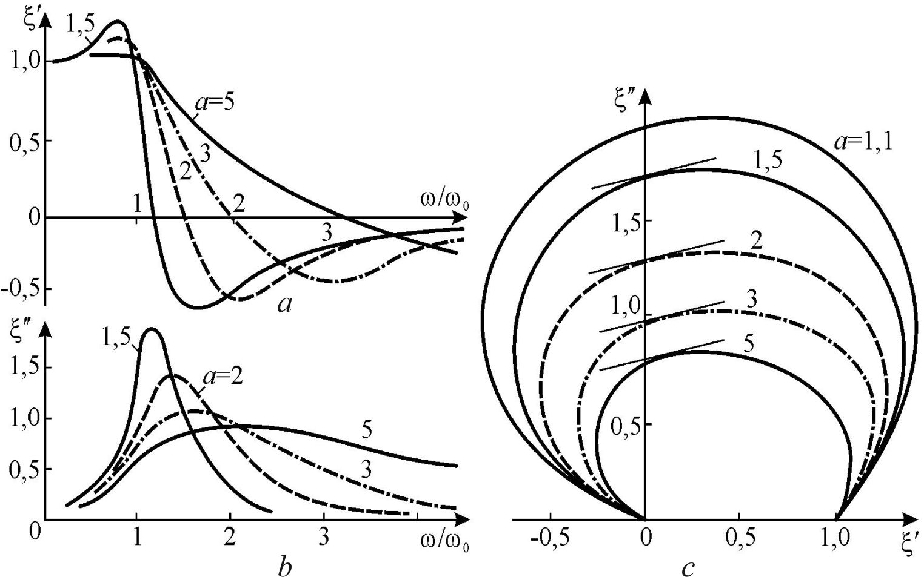

Fig. 4.17. Distributed oscillators modelling with different distribution parameters a = 1,5...5:
a and b – frequency dependences of ξ' і ξ" at Г = 0,5; c – graph ξ"(ξ') for Г = 0.5

In the Fig. 4.16 the experimentally obtained dielectric spectra of barium titanate at 300 K was shown, as well as a diagram ε″(ε′) in the region of microwave ε-dispersion. If apply the above method for determining the parameters a and Г, it can be shown that the frequency dependences of ε′(ν) and ε″(ν) in the section 2 of Fig. 4.16, b) correspond to the theoretical calculation with the parameters Ω₁ = 4 GHz, а = 2 и Г = 1.

4.8. Normal distribution of relaxation oscillators and oscillators

Diffuse ε-dispersion spectra can occur for various physical reasons. An obvious case is dielectric with polar groups, which are characterized by different Debye relaxation time (or different resonant frequency – in the case of Lorentz model). If that is so, the dispersion spectrum extension for relaxation polarization can occur as a result of the interaction of polarized particles.
The potential barrier that particle must overcome during relaxation in the case of neighbouring particles interaction can have several meanings, depending on the state of neighbouring particles. Because the relaxation time τ depends on the height of this potential barrier, it is expected that the relaxation time might have several different values.
The assumption of relaxation times normal (Gaussian) distribution is the most natural to take into account the fluctuation of the proper frequency (Ω₀ = τ^{–1}) deviations from a middle frequency (similar argumentation will be applied for oscillators).
The reason of relaxation times distribution can be, for example, a deviation of the potential barrier from average value U₀. Since Ω ~ exp(–U/k_{B}T), the assumption of normal distribution of potential barrier height should lead to a Gaussian distribution of frequency logarithm:
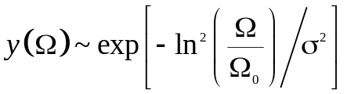, (4.21)
where value of Ω₀ is determined by the average barrier U₀, and σ is parameter of normal distribution (half-width of Gaussian "bell").
The reason of discriminatory oscillator distribution is obvious in the heterogeneous dielectrics. But even in single crystals, which are characterized by significant anharmonicity of lattice vibrations (ferroelectrics), the fluctuation-type distribution of the potential barriers that should be overcome by the charged particles during their movement in the anharmonic potential, is also possible.

Normal distribution of relaxation oscillators. Substituting the distribution function (4.21) in the general expressions, and normalizing the ε* for the value of the dielectric contribution, it can be obtained:

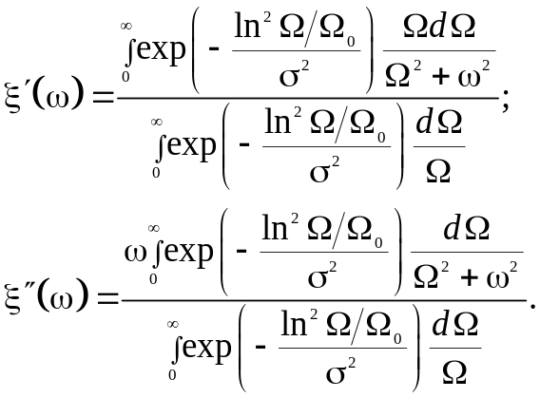

After the change of variables: introducing notation ln(Ω/Ω₀) = z and х = ω/Ω₀, it can be obtained:
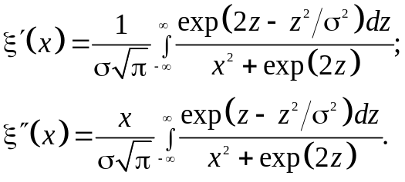 (4.22)
Results of ξ′ and ξ″ calculations using these formulas for the values of Gaussian distribution parameter σ = 0.1...10 are shown in Fig. 4.18. In some cases (as for large so for small σ) the obtained expressions can be approximated by simple formulas that simplify ξ′(х) і ξ″(х) calculations at all frequency range.

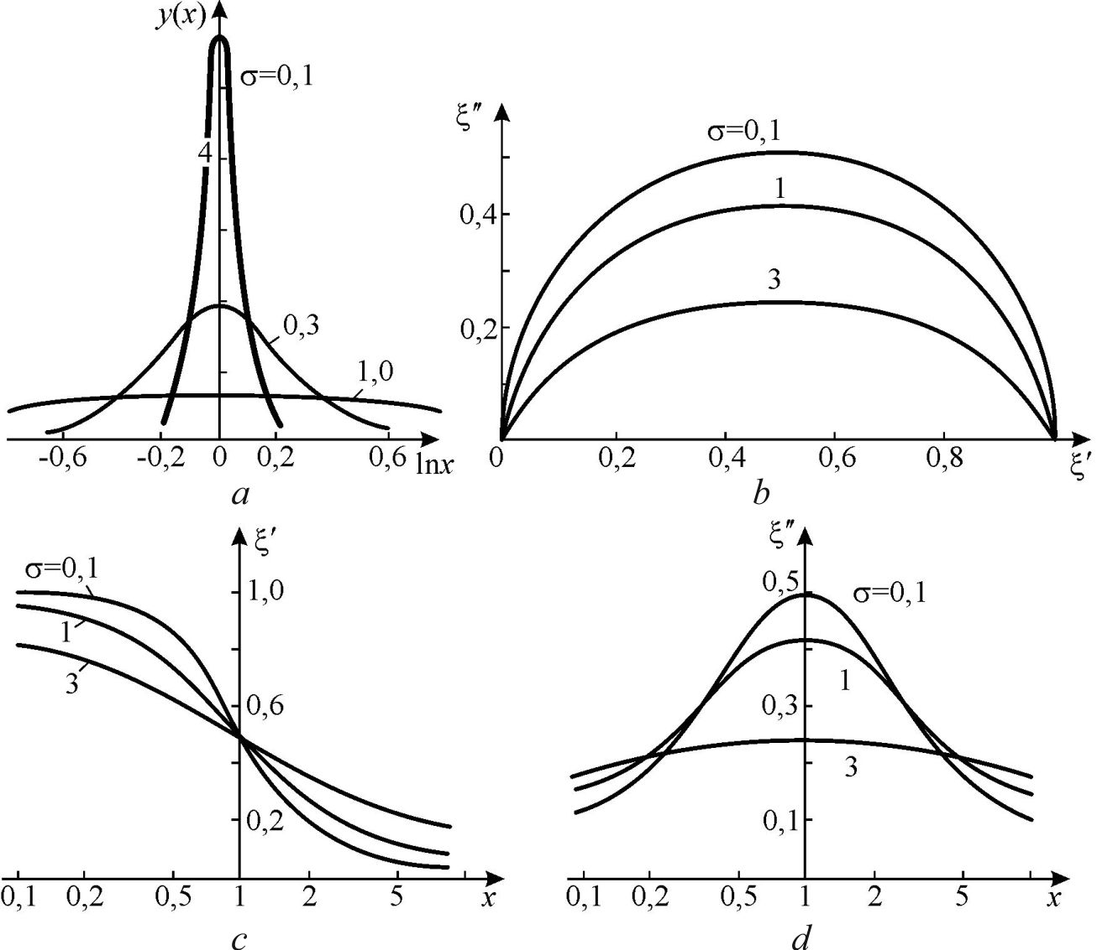
Fig. 4.18. Normal distribution of relaxation oscillators: a – Gaussian function graphics;
b – diagram ξ"(ξ') for different values ​​of distribution parameter σ;
c, d – ξ' and ξ" dependencies on normalized frequency х = Ω/ω

Normal distribution of Lorentz oscillators can be considered in a similar way. Using the distribution function (4.21) and corresponding integral expression, after normalization it is possible to obtain:
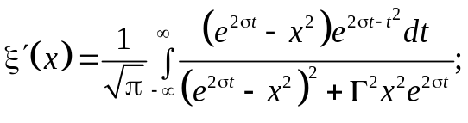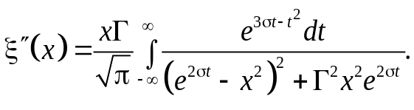
Calculations ξ' and ξ" at different values of distribution parameter σ and attenuation Г were carried out using a computer. Some results of these calculations are shown in Fig. 4.19. By analogy with the normal distribution for values σ² < 1, the integrals can be decomposed in a rapidly convergent series, and thus obtained the analytical expression that can be used for calculations in the case of the "narrow" distribution of the oscillators. These expressions are cumbersome and they are not mentioned here: Gauss distribution is convenient to simulate by the uniform distribution.
In this case, as shown in Fig. 4.19, the “bell-type” Gaussian function is replaced by a rectangle, and the parameters σ and a as easy to relate to each other.
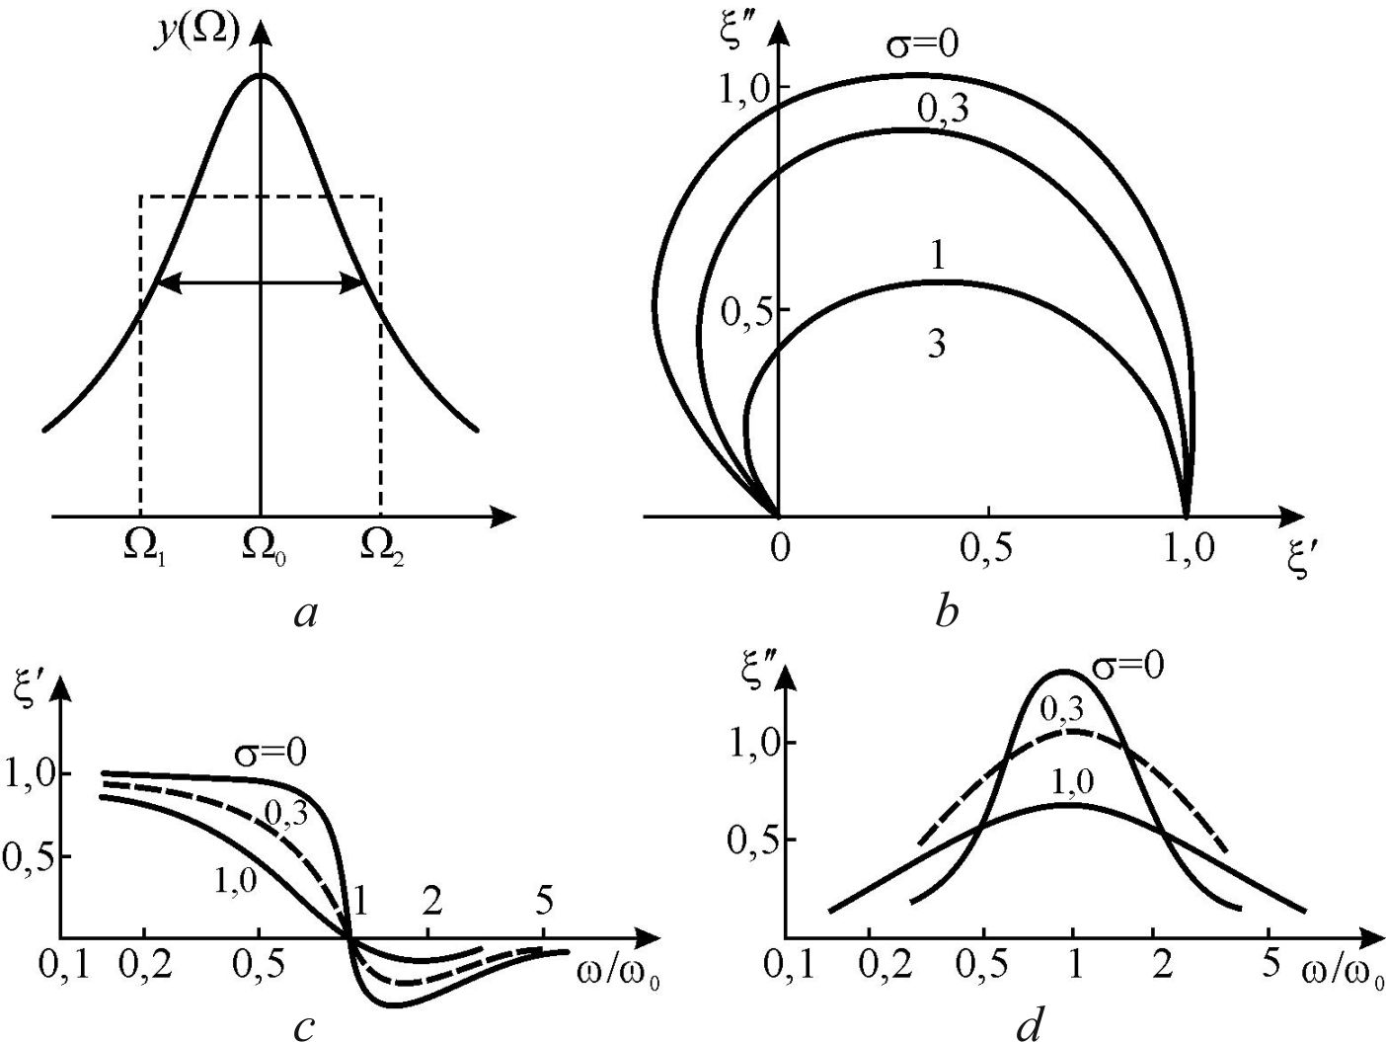
Fig. 4.19. Normal distribution of oscillators: a – Gaussian function and its modelling by rectangle; b – diagram ξ"(ξ'); c, d – frequency dependence of ξ' and ξ"'ξ at Г = 1

Comparison of relaxation oscillator and Lorentz oscillator models. Considerable interest and, at the same time, the greatest difficulty is the case when experimental dependence ε*(ω) is described by the dispersion of the oscillator with very high attenuation (Г > 1). This phenomenon is often observed in studies of ferroelectric and polar polymers.
In this case, within the measurement error, there may be uncertainty in the choice of model of dispersion: it can be used as a dispersion formula of Debye so Lorentz model of over-damped oscillator. In addition, there may be grounds for regarding the distribution of oscillators describing frequency dispersion.
The dependence of the main parameters of dispersion spectrum on the relative damping is shown in Fig. 4.20. The normalized (by the amount of the contribution of the dielectric) parameters are investigated: the maximum of losses; the permittivity minimum in the vicinity of dispersion; the width of spectrum (i.e., relative width of absorption area Δω/ω); the ratio of the frequency dispersion to the oscillator frequency (dispersion frequency corresponds to the maximum absorption of the oscillator).
The graph in Fig. 4.20 shows that in the case of large attenuation (Г > 4) and at the error of attenuation measurements 10% it is impossible to determine what dispersion equation – Debye (relaxation) or Lorentz (oscillatory) – should describe experimental data. If the error of ε″ measurement reaches 20%, the difference in the absorption maximum for relaxation oscillator and Lorentz oscillator becomes invisible even at Г > 2.5.
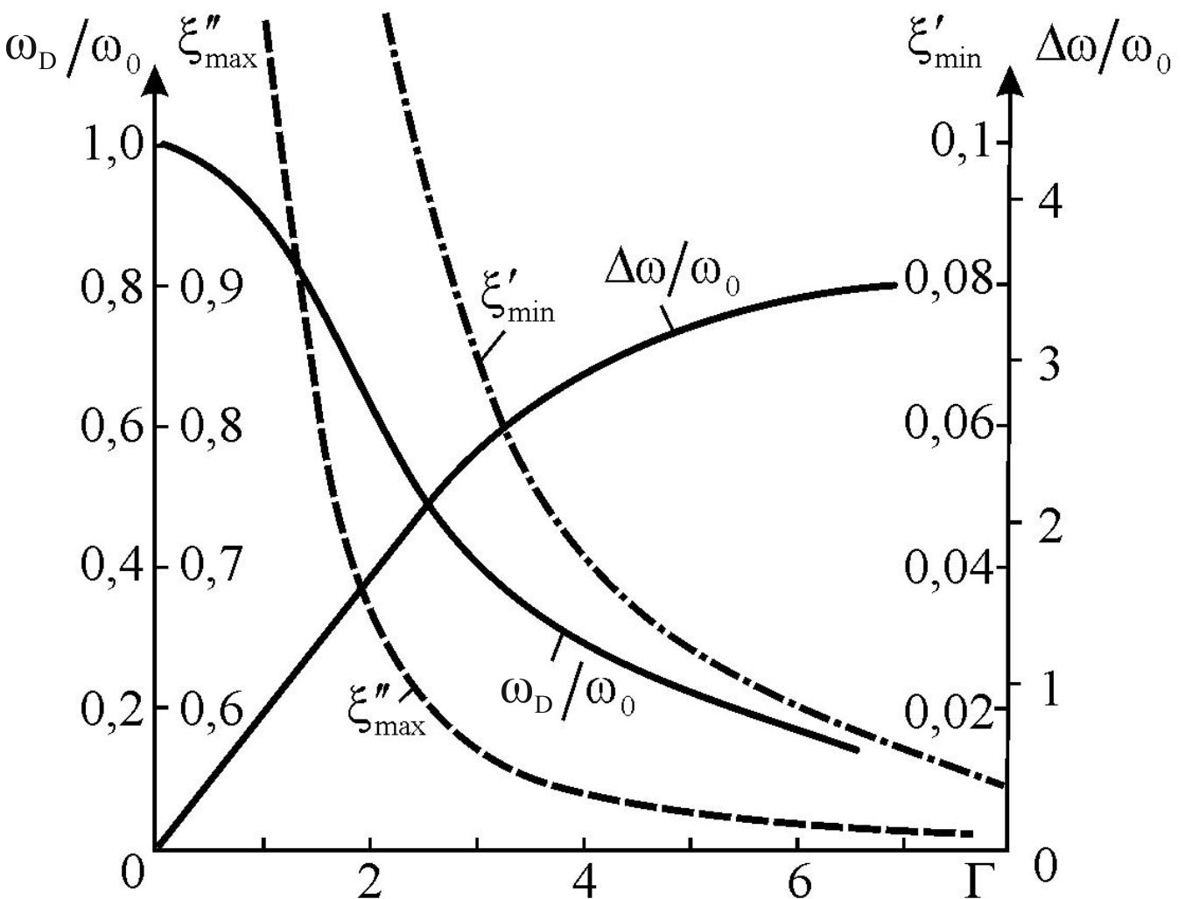

Fig. 4.20. Relative damping Г of oscillator influence on normalized permittivity maximum (ξ″_{max}) and minimum (ξ'_{min}); ratio of relaxation frequency ω_{D} to frequency ω₀;
ratio of spectrum width Δω to maximal absorption frequency ω₀

Spectral width increases substantially proportional to the attenuation only if Г < 2; then the dependence of Δω/ω₀ on the value of Г becomes more flat and for large Г approaches to the width of the Debye spectrum: 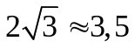. If the error of losses measurements loss is about 10%, the difference between the oscillator and the relaxation-oscillator dispersion formulas can be seen by the spectral width Δω/ω, but at the values Г < 3.
A characteristic detail of the permittivity frequency dependence in oscillator model in the case of big damping is the presence of minimum ξ′_{min} = [Г(Г+2)]^{–1} in the range of dispersion. As it is seen in Fig. 4.20, the ξ′_{min}(Г) varies considerably even at large values of Г.
Measurement error is much smaller for resonant measurement methods, which mainly are used in the microwave range, allowing determination of permittivity with an error of about 2%. In this case, it can be concluded about the possibility of describing the model variance, even when value of Г = 5... 6.
Independent of the value of Г is a position of the effective conductivity maximum that is used to determine the frequency of the oscillator ω₀, as well as the value of Г using the difference in frequencies ω₀ и ω_{D}. This method can be used, if the attenuation value Г < 5, otherwise, with the increasing of attenuation the dependence becomes too "flat".
Theory, which combines the oscillator model and the relaxation-oscillator, was developed in the works of L. Van Vleck and H. Frohlich. This is a model of the rotator in a state of continuous collisions, i.e., the rotator, located in the "viscous medium". It was shown that the Debye dispersion formula is deficient in the high frequency range (above the frequency dispersion). The correction of the Debye formula, which is sometimes called "inertial correction", leads essentially to the dispersion equation of over-damped oscillator.

4.9. Properties of inhomogeneous dielectrics

Inhomogeneous dielectric is made up of different components with various electrical properties. Materials of electronics and electrical equipment, in particular, are often the heterogeneous composite materials, i.e. are mixtures of two (or more) different materials, i.e. they are the mixture of several components. For example, they are plastic mass (with main components – the filler and polymer) or porous fibrous materials, etc. Quite common, for example, is the layered insulation made from various polymeric films. The non-uniform material is also dielectric ceramics: it consists of a crystalline phase, glassy layers between crystallites and gas pores (usually, pores are not desirable, but inevitable). However, in the microwave technique, to reduce the permittivity of the dielectric, especially porous inhomogeneous foam-dielectrics and ceramic foam are used.
Next, the basic laws, which are used for calculating the parameters of a mixture of given composition are considered (in the first place, dielectric constant and losses of mixture), as well as for the calculation of the composition of the mixture, which should have the desired properties.
During consideration of the matter, it is assumed that mixture is a physical, that is, its components do not come together in a chemical reaction. In addition, the review is made at the macroscopic level, without going into the details of the structure (grains, layers and other parts of components of the mixture contain an enormous number of molecules). Thus, it is supposed that the size of the inhomogeneities is bigger than "physically infinitesimal volume" of Lorentz sphere, and therefore, each component of the composite can be described by its own value of ε and tanδ.
A theoretical study of heterogeneous dielectrics reduces to the calculation of composite effective permittivity ε_{ef} and effective dielectric loss tangent tanδ_{ef}. Some different models of heterogeneous dielectrics are considered, providing estimation of their parameters.

Two parallel-connected dielectric, Fig. 4.21. As the known parameters, ε₁, ε₂, tanδ₁ and tanδ₂, as well as surfaces S₁ and S₂ are considered. Need values of ε_{ef} and tanδ_{ef} are calculated on the base of the parallel equivalent circuit of the composite structure. Obviously, the value of the equivalent capacitance is the sum: С_{пар} = С₁ + С₂. Accordingly, the effective dielectric constant:
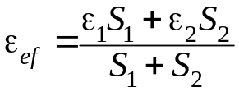.
The effective loss tangent is:
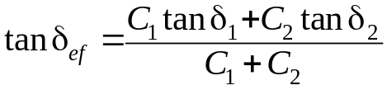
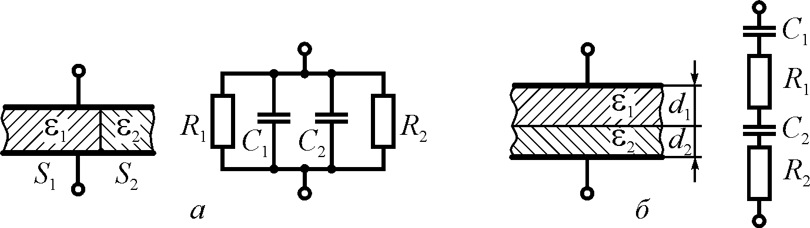

Fig. 4.21. Introduction of inhomogeneous dielectric with losses as parallel (a)
and series (b) connection of different dielectrics

Randomly distributed, but connected in parallel dielectrics. In an inhomogeneous dielectric, which is made up of two components, their distribution can be arbitrary, but the location of components is assumed to be the same as in Fig. 4.21, a. It should be also known the relative concentration of the components x₁ and x₂. An example of such composite structures may widely distributed in electronic components technique, for example, ceramic piezoelectric narrow bars (ε₂ ~ 1000) in a polymer (ε₁ ~ 2) as is it was shown in the Chapter 1, Fig. 1.23.
This case is a generalization of the previous one. Effective dielectric constant is equal to:
ε_{ef} = х₁ε₁ + х₂ε₂, (4.23)
and the effective dielectric loss tangent:

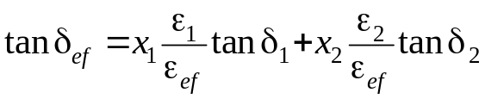.

Two series-connected dielectric layers with different parameters, Fig. 4.21 b. Known parameters are ε₁, ε₂, tanδ₁ and tanδ₂ as well as layer thicknesses d₁ and d₂; the squares of layers are the same: S₁ = S₂ = S.. In the case of small dielectric loss value of the equivalent capacitance:
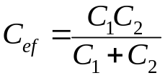.
Accordingly, the effective dielectric constant is:
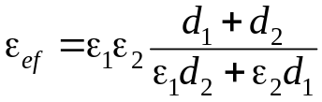. (4.24)
The equivalent circuit of Fig. 4.21, b, allows to find value of dielectric loss:
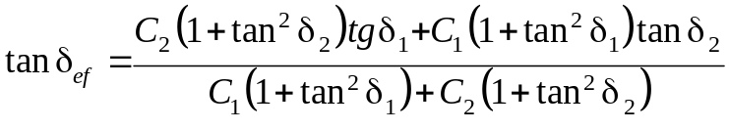.
Assuming small losses, that is almost always may be implemented in practice, this formula can be simplified:
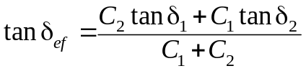.
Distributed series-connected layers of two dielectrics is generalization of the previous case. The bulk density of the first and the second components are denoted as x₁ and x₂. The value of the loss tangent in this case can be determined as:

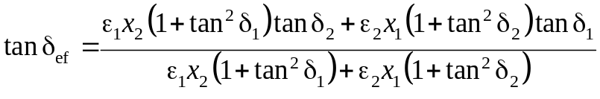.
Effective dielectric permittivity is:
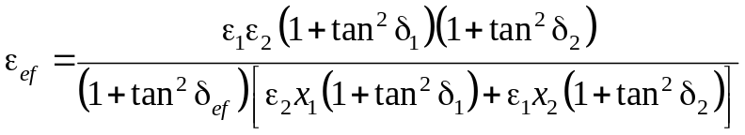
In the case of small losses this equation is simplified:
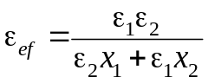 . (4.25)
Statistical mixture (arbitrary distribution of inhomogeneous). Although in some cases, to calculate the value of the effective permittivity of composite dielectrics, and can be applied formula, the receipt of which is based on using a simple model, in most cases of practical importance composite insulators are chaotic (statistical) mixture, in which the grain-components are arranged randomly in space, chaotically. In this case, as already equivalent circuit shown in Fig. 4.21 are unsuitable, and therefore not valid above mentioned formulas, derived on the basis of these schemes. The true value of the effective permittivity ε_{ef} of statistical mixture must be between the values, arising from the formulas (4.23) and (4.25); this situation is called "Wiener inequalities":
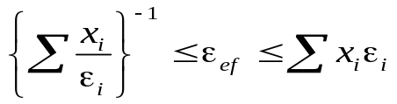(4.26)
and clearly illustrated by the graphs in Fig. 4.22.

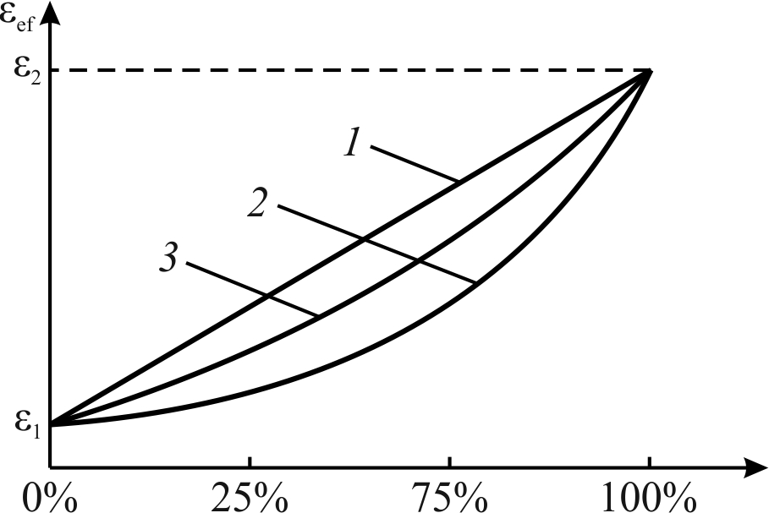

Fig. 4.22. Dependence ε_{ef} on volume contents of components:
1 – parallel circuit (Fig. 4.21, a); 2 – series circuit (Fig. 4.21, b); 3 – statistical mixture

In the formula (4.26) using the same notation as before: ε_{ef} is effective dielectric constant of the mixture, ε_{i} is permittivity of mixture components, x_{i} is volume concentrations of the components in the mixture.
Researchers proposed a large number of formulas for statistical mixtures dielectric constant calculation; most of them are based on different theoretical assumptions and different experimental data. The physical properties of mixtures may be different, and different methods of ε_{ef} и tanδ_{ef} calculation were proposed, but all calculations are very approximate. The theoretical calculations with experimental data coincidence, as a rule, are the better the less different are parameters of the components.
The most widely used is a convenient for calculation is K. Lihtenekker formula, otherwise – the logarithmic law for the mixing of two components:

logε_{ef} = х₁logε₁ + х₂logε₂. (4.27)
If apply this formula to complex permittivity: ε* = ε′ – iε″ = ε′ – iε′tanδ, then it might be shown its validity for loss tangent:

log(tanδ_{ef}) = х₁log(tanδ₁) + х₂log(tanδ₂). (4.28)

Generally, the known parameters are dielectric permittivity and losses (ε₁, ε₂, tanδ₁ and tanδ₂) as well as the bulk concentration of the components (x₁ and x₂), and it needs to define the ε_{ef} and tanδ_{ef} of a mixture. However, sometimes the problem is posed differently: to find ε and tanδ of one component of a mixture using known parameters mixture and second component.
It should be noted that the formulas for the calculation of the conductivity σ_{ef} and permeability μ_{ef} for mixtures are similar to the formula (4.27).
For the matrix mixture in which some "main" material with permittivity ε_{m} contains the "weighted" impurity particles with permittivity ε_{p} the Maxwell- Wagner relation is used:
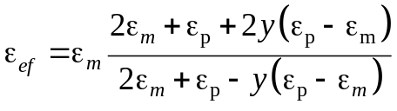, (4.29)
where y is relative volumetric concentration of impurity components. Based on this formula (assuming its validity for ε*) the calculations of the dielectric losses of matrix mixture can also be performed.

Summary to Chapter 4

1. Dielectric losses are the part of electrical energy that is converted into a heat. For quantitative description of dielectric loss, there are three main parameters that characterize losses in dielectrics: heat power density p, loss coefficient ε″ and loss tangent tanδ. They are depicted as:
p = σE², ε* = ε′ – iε″, tanδ = ε″/ε′, tanδ = σ/(ε₀ε′ω), σ = ε₀ωε″,
where ε* is complex permittivity that consists of real (ε′) and imaginary (ε″) parts, while σ is specific conductivity which determine the loss coefficient.

2. The frequency and temperature dependence of dielectric losses are determined by distinctive physical mechanisms that define the electrical energy dissipation of in dielectric. The most important of these mechanisms is the conductivity and the tardiness of thermally activated polarization.

3. Mechanisms of dielectric losses are quite different. In the case of elastic polarization the dispersion of complex permittivity ε*(ω) has a resonant character, so frequency dependence of ε′(ω) demonstrates not only a maximum, but also a minimum, while the loss factor ε″(ω) in the vicinity of resonant dispersion shows rather sharp peak. In the case of thermal polarization, the dispersion of permittivity has a relaxation nature, that is characterized by frequency decline of ε′(ω) and by a broad maximum of ε″(ω).
4. Magnitude of the losses, as well as their dependence on frequency and temperature indicate certain features of polarization mechanism. Microscopic source of losses might be as conductivity so anharmonicity in lattice vibrations. As a rule, conductivity influence at microwaves is minimal. The primary cause of the anharmonicity in crystalline dielectrics is determined by the asymmetry in the electron density distribution along the atomic bonds. This is conditioned by the differences in the electro-negativity of atoms. Sometimes the distinction of different atoms in their electro-negativity might be large. Atom with higher electro-negativity strongly attracts the electron-pair bond, so his true charge becomes more negative. Atom with a lower electro-negativity acquires, respectively, the increased positive charge. Together these atoms create a non-harmonic polar bond.
5. Dielectric losses at high frequencies might be the footprints of:
• Phenomenon of conductivity.
• Slow polarization relaxation (electronic defects, ionic defects, various kinds of dipoles, etc.) which are described by the Debye model of relaxation.
• Different kinds of structure imperfections results in frequency-diffuse dielectric spectrum that is depicted by the Cole-Cole model.
• Resonant mechanisms of fast polarization that are described by the Lorentz oscillator model.
• In the non-centre symmetric dielectrics and semi-conductors microwave loss factor governs by the very high frequency polar mechanism of losses.

6. Frequency dependence of dielectric absorption is convenient to describe by the complex permittivity: ε* = ε′ – iε″. Delay of polarization leads to ε′ decrease with frequency that is accompanied by ε″ maximum. In the case of thermally induced polarization the ε* frequency dependence is described by the Debye relaxation equation, and for the quasi-elastic polarization is described by the resonant Drude-Lorentz equation.

7. The dispersion of the dielectric constant is the correlated change of the real and imaginary parts of ε* with frequency alteration. The main properties of the ε* dispersion is the fulfilment of the Kramers-Kronig relations, to which should satisfy any dispersion equation. In the wide range of frequencies and temperatures, as well as in the different crystallographic directions dielectrics typically observed several dependences of ε*(ω,Т), which form the dielectric spectrum.

8. Relaxation dielectric dispersion is characterized by a gradual decrease of ε′(ω) with increasing frequency over the entire spectrum (i.e., dε′/dω < 0). Diffuse over the frequency range relaxation spectra can be described by different empirical formulas, as well as by a model of normally distributed relaxation-oscillators.

9. Resonant dielectric dispersion has a region (or some regions) of the spectrum, where dε′/dω > 0. Expanding resonance spectrum can be explained as by increased damping of model oscillator or by the distribution of the oscillators in the frequency range.

10. Technical dielectrics very often are heterogeneous materials (low-frequency insulation made from various polymeric films, as well as various high-frequency ceramics and composites). Calculation of the effective permittivity ε_{ef} and dielectric loss tangent tanδ_{ef} can be made on the basis of various models.

